Project:

GitHub repo URL: <https://github.com/shubhnim/devops-build>

Docker Images: https://hub.docker.com/repositories/shubhnimdocker/

Fork the application:

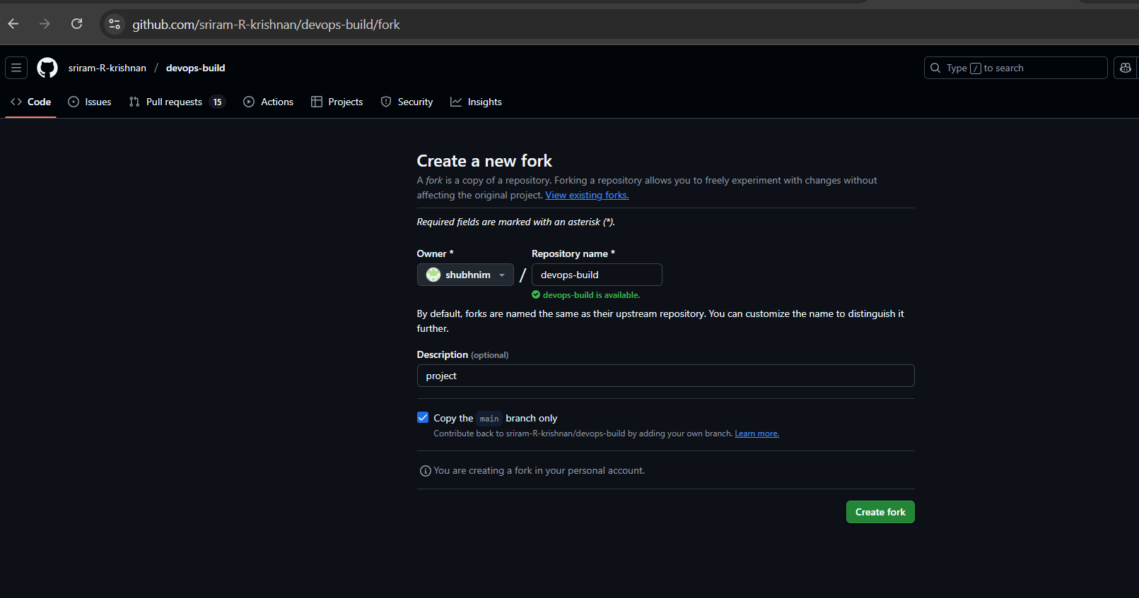

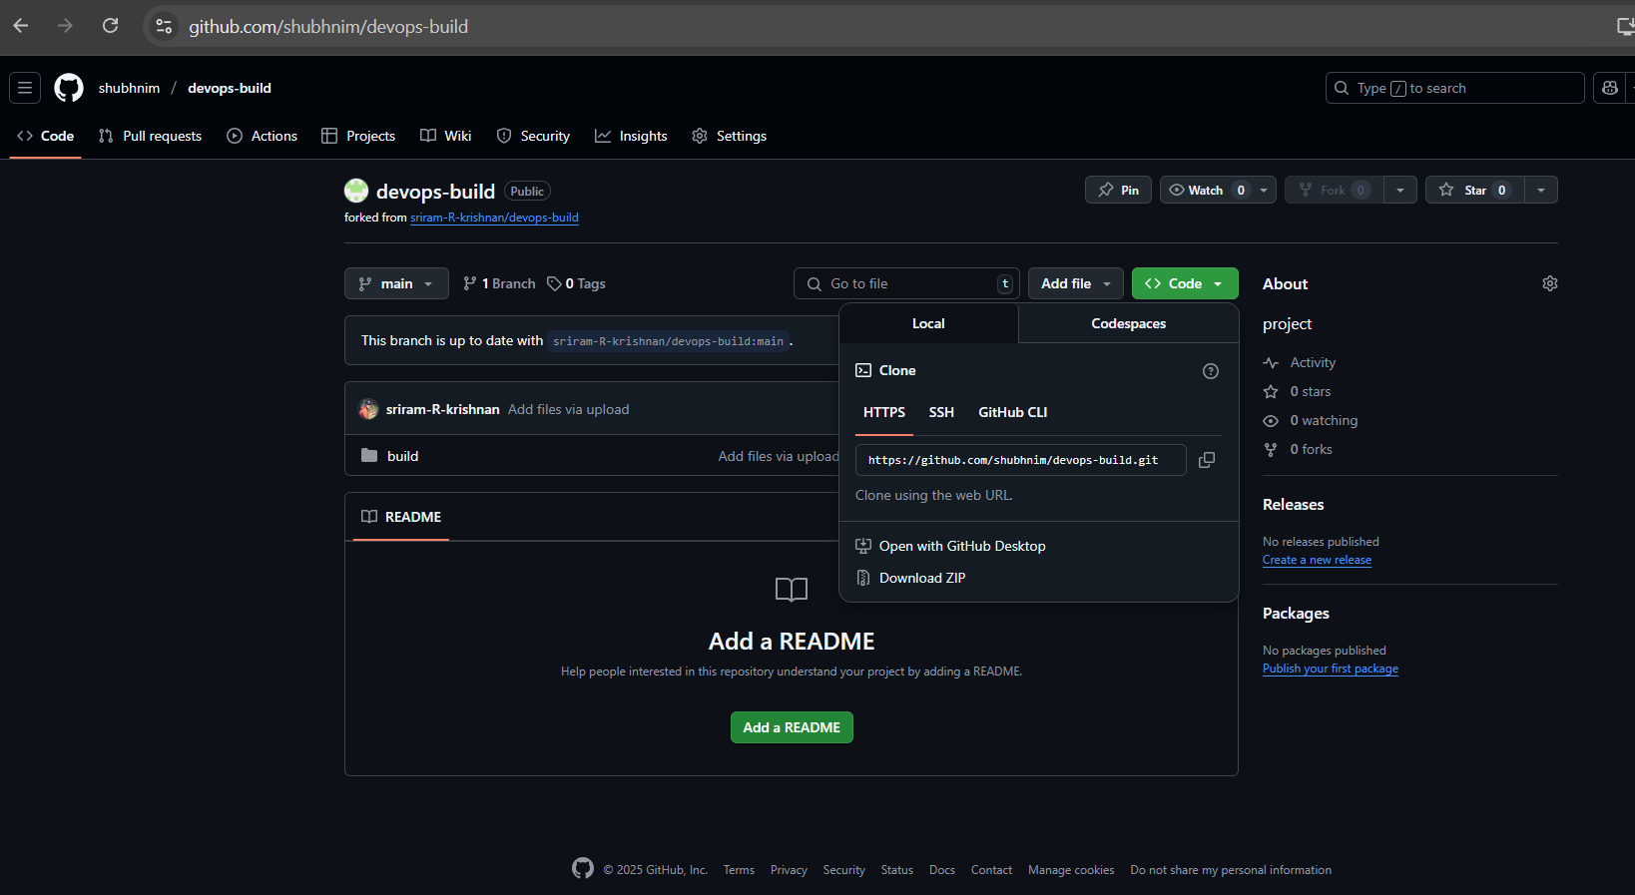

Clone the Fork Locally:

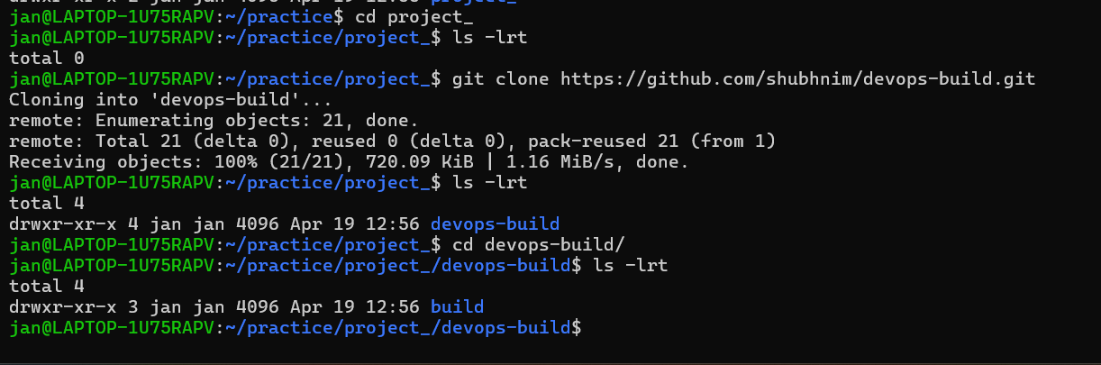

Docker:

Dockerize the application by creating a Dockerfile

create a docker-compose file to use the above image

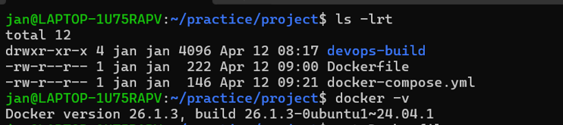

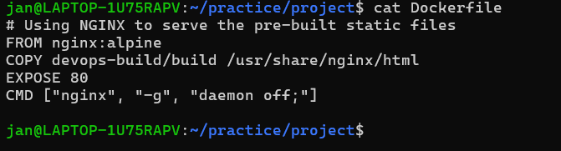

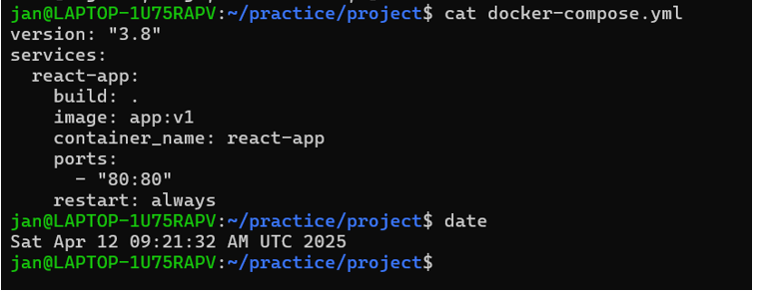

Bash Scripting:

Write 2 Scripts

build.sh - for building docker images

deploy.sh - for deploying the image to server

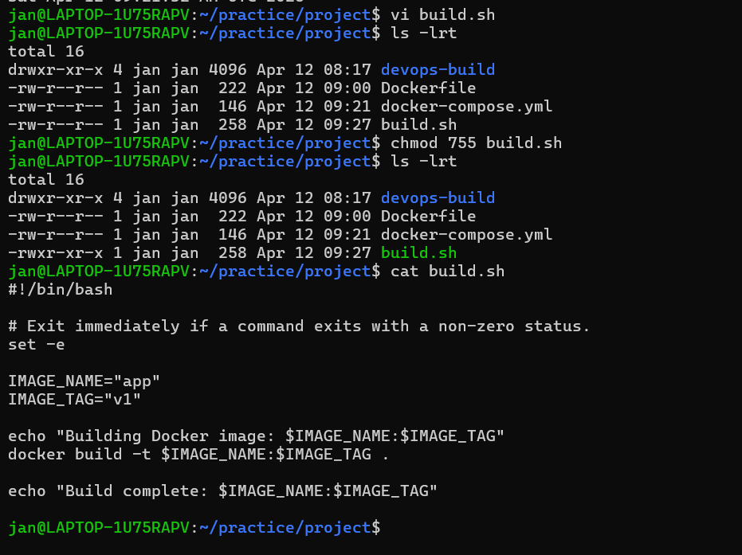

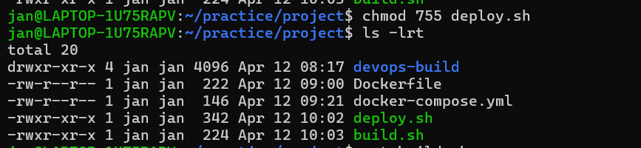

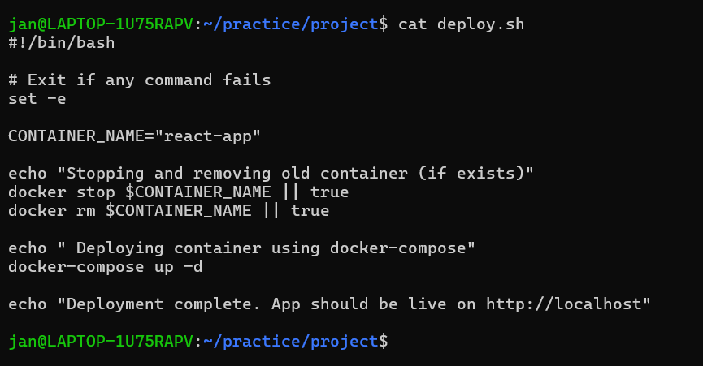

Before building, adding a .dockerignore file to prevent unnecessary files from being copied into the Docker image

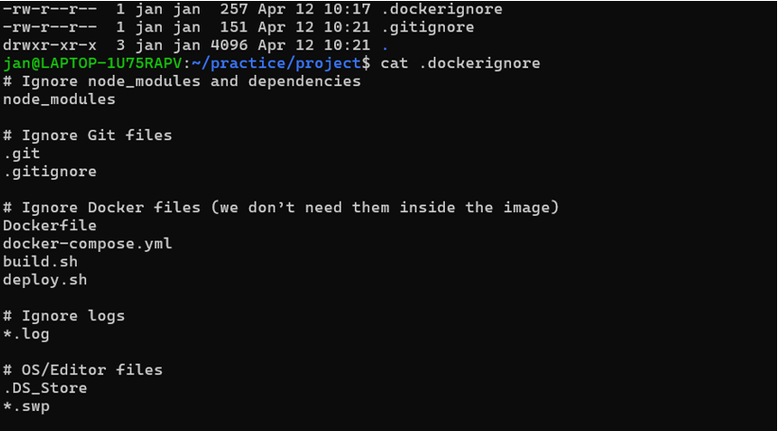

Also adding .gitignore file

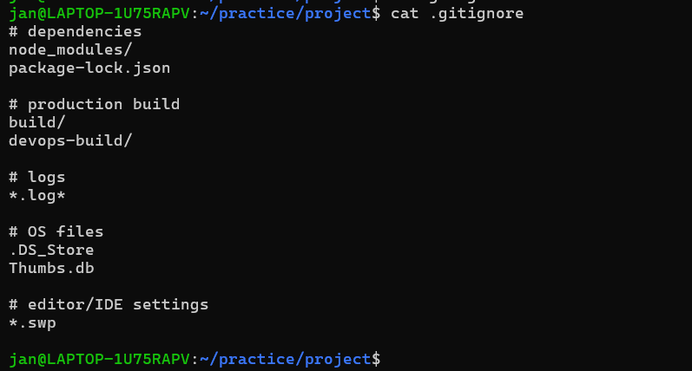

Moving all files to my final project directory:

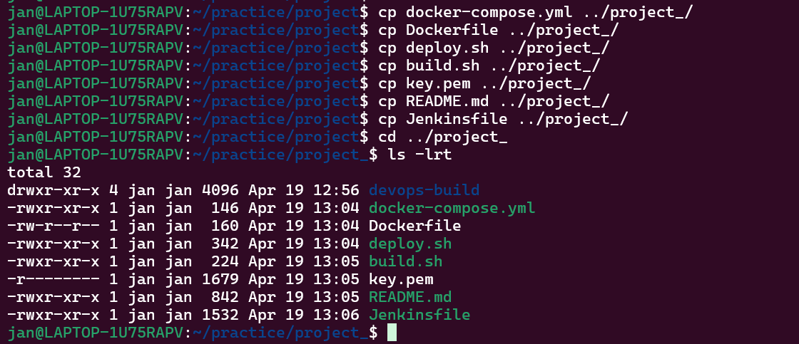

build.sh:

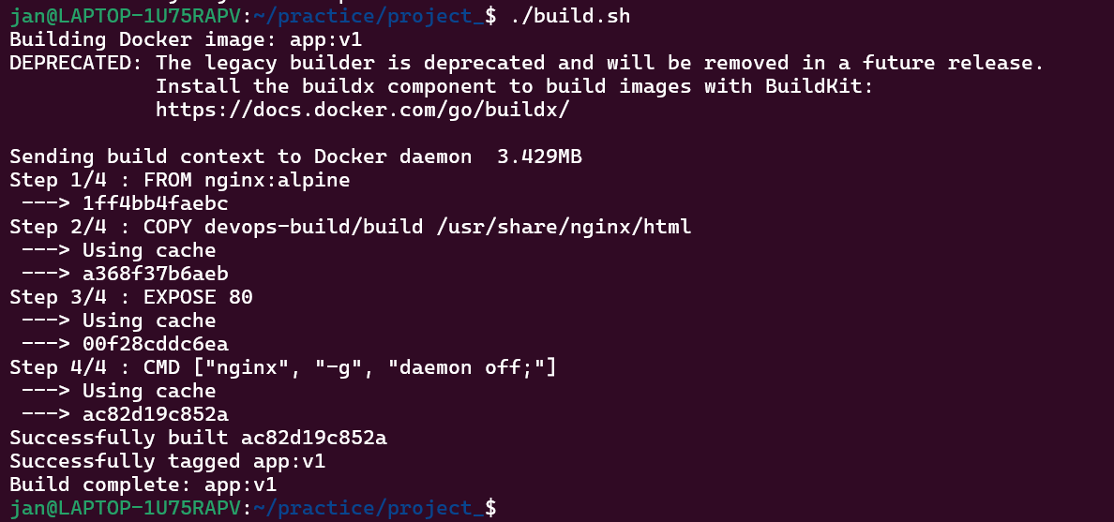

I was getting error while running script : deploy.sh   
port 80 on my local machine was already being used. So I stopped the process which was using port 80

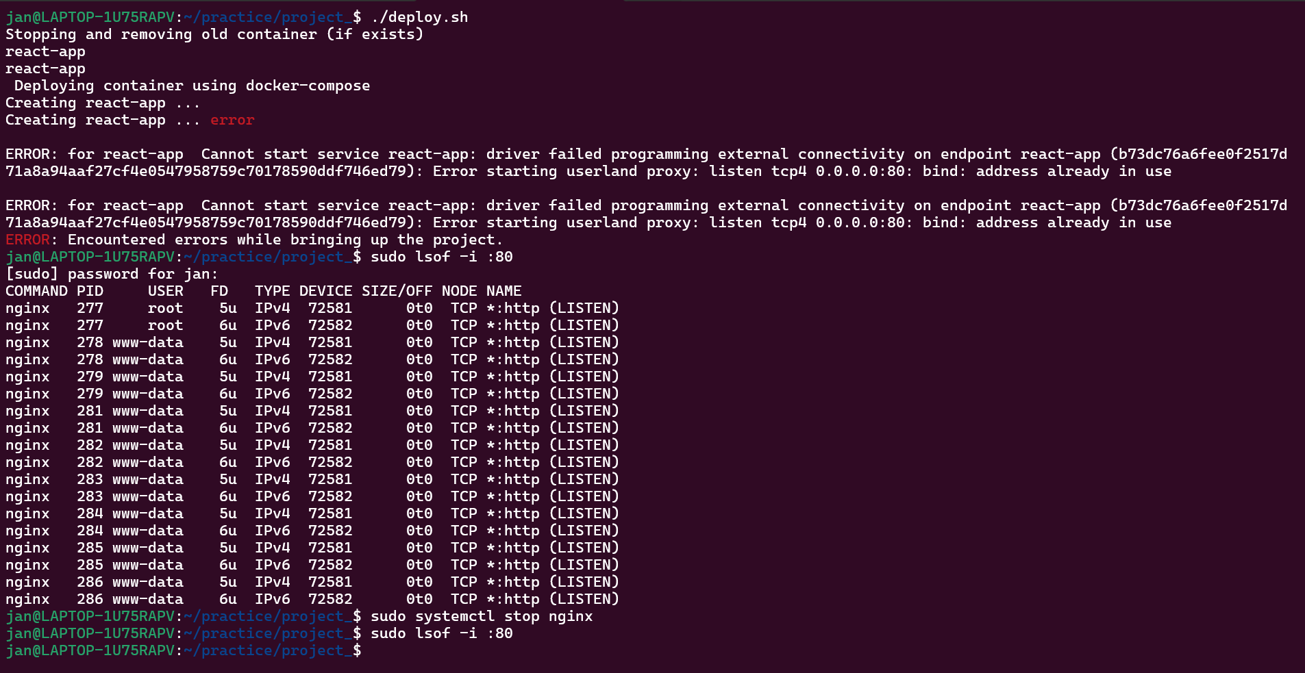

deploy.sh:

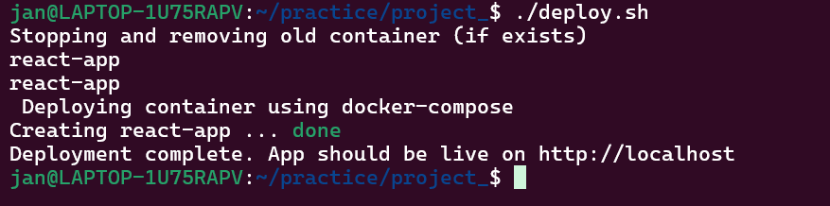

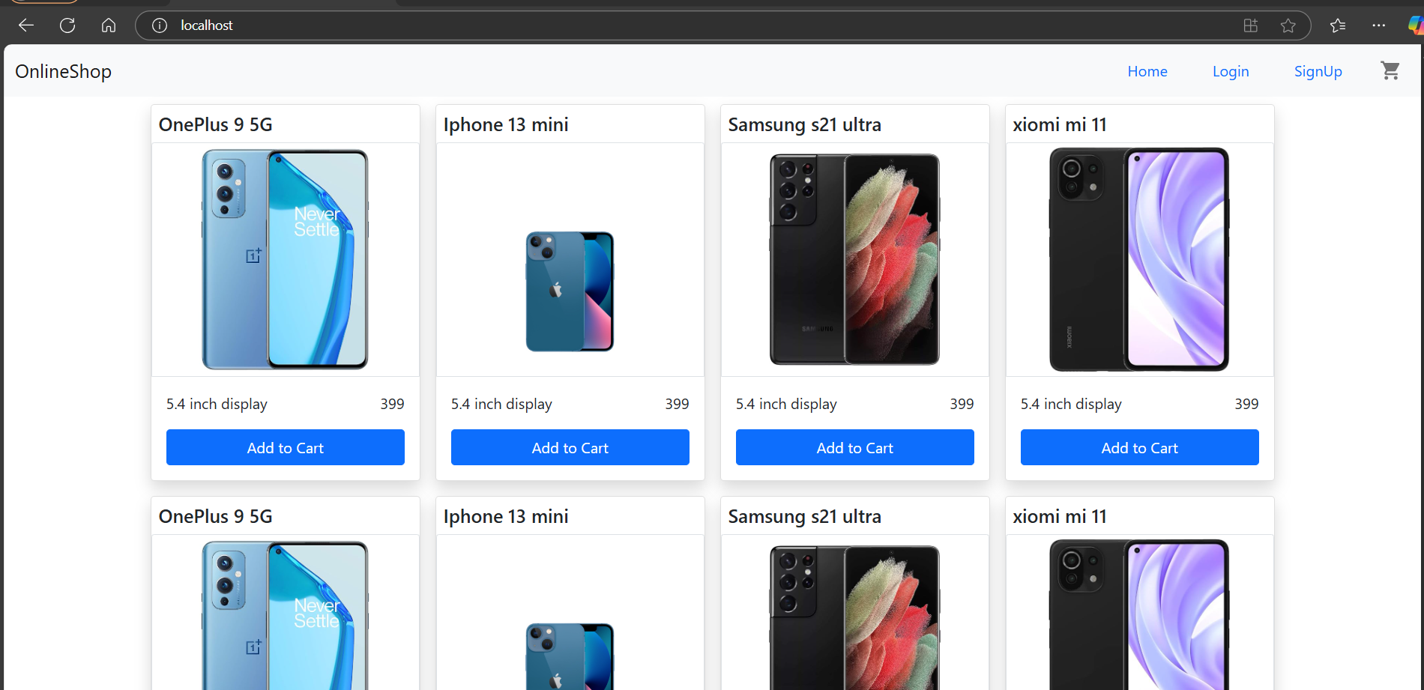

App is up and running fine locally.

Version Control:  
  
.dockerignore & .gitignore files are already created above.

Push the code to github to dev branch

successfully initialized a Git repository in project directory:

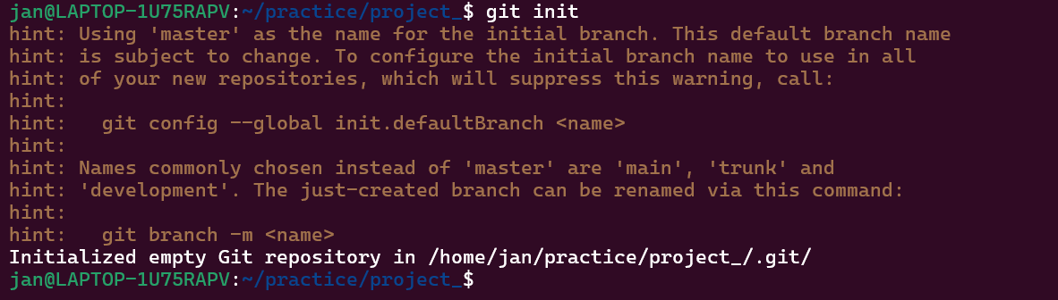

I was getting error while doing git add .

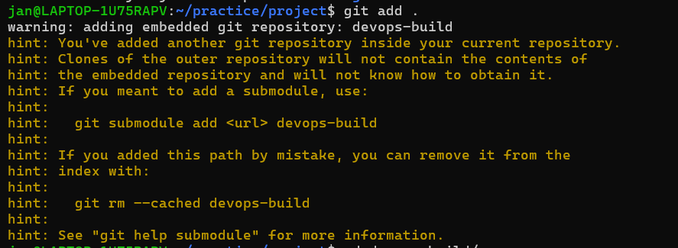

Removed the devops-build directory from the main repository

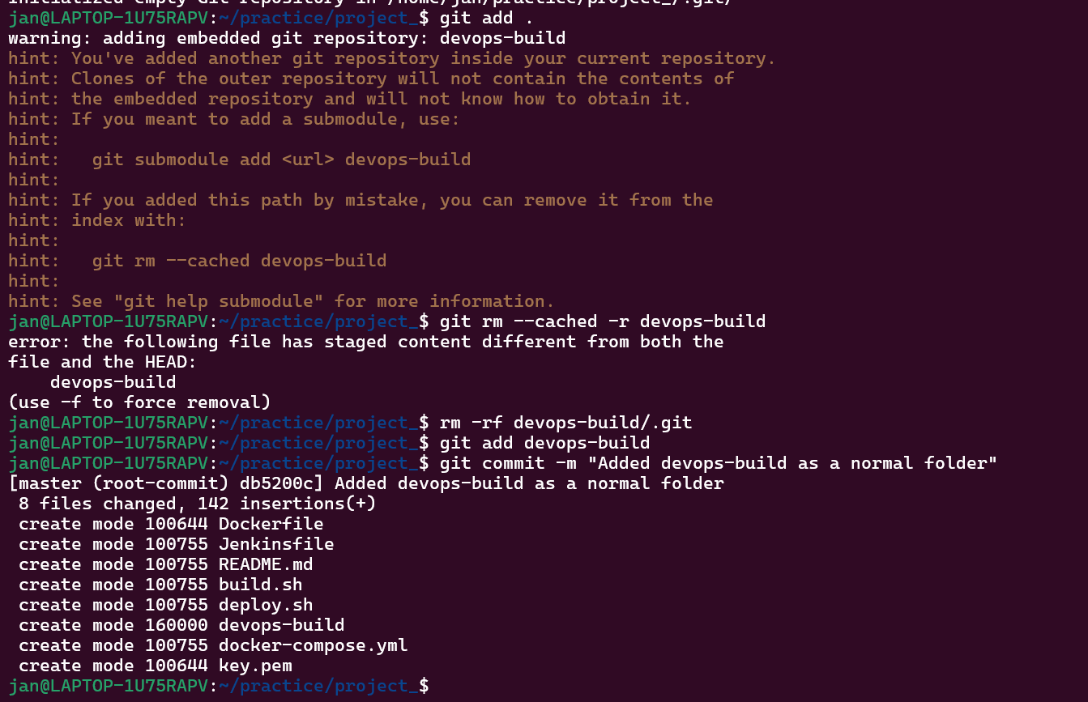

Added devops-build to .gitignore file and then added the .gitignore change

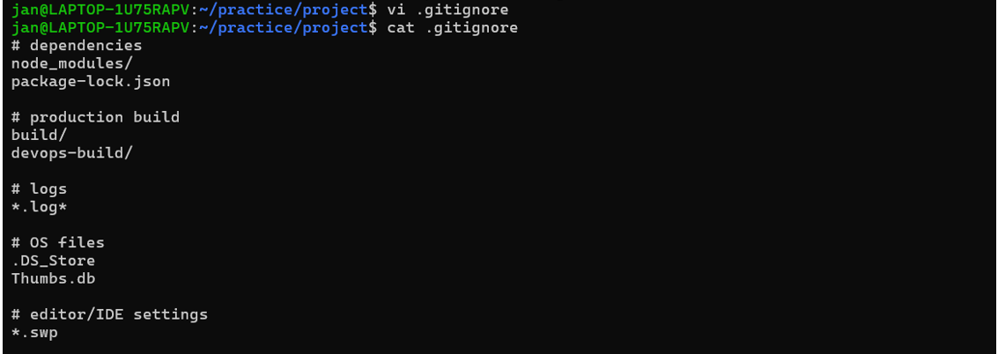

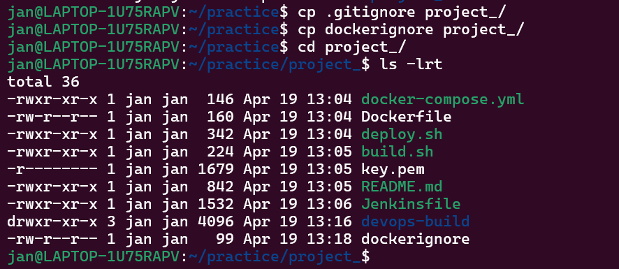

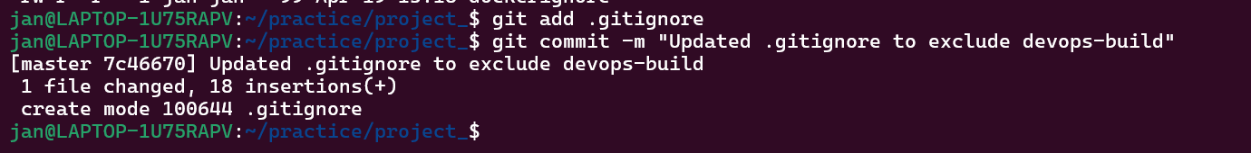

So till now Local Git repo initialized and committed.

Create and Switch to dev Branch:

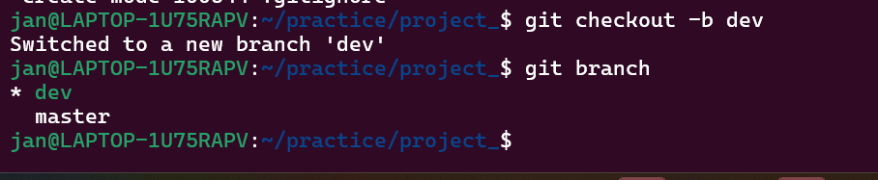

Push dev Branch to GitHub

Used Personal Access Token (PAT)

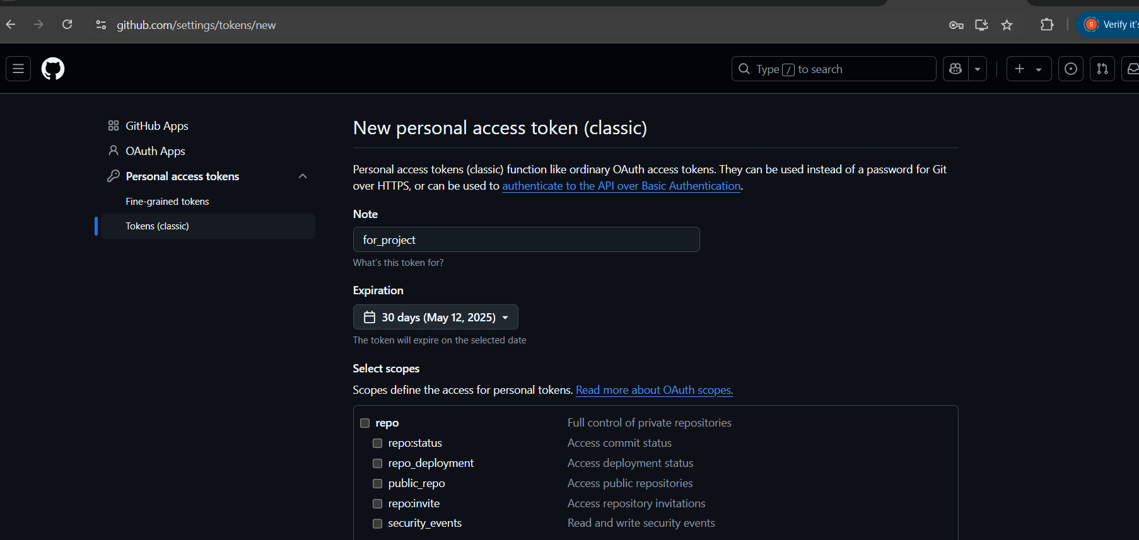

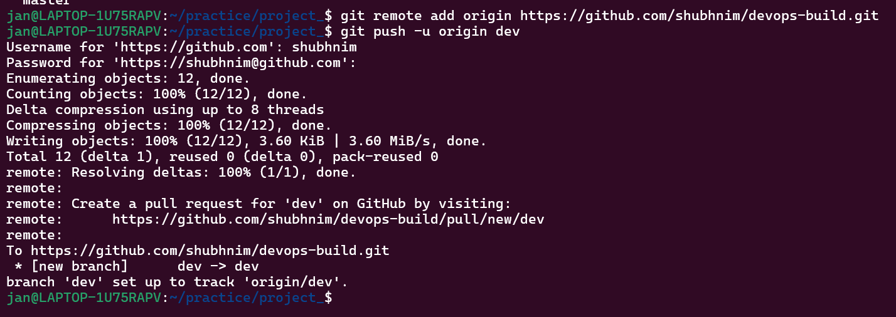

Pushed code to GitHub (dev branch)

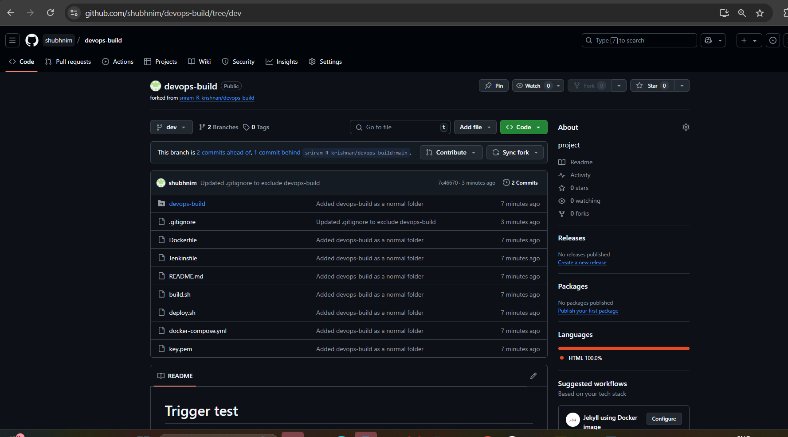

Docker hub:

Create 2 repos "dev" and "prod" to push images.

"prod" repo must be private and "dev" repo can be public

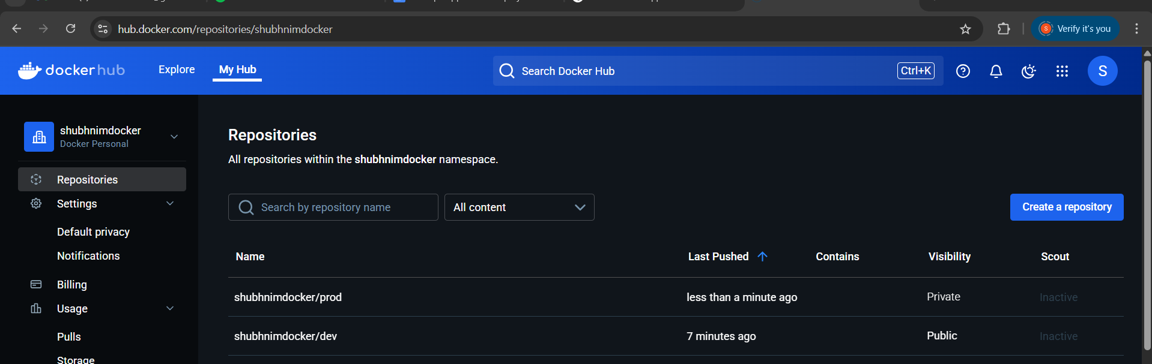

logged into Docker Hub via CLI:

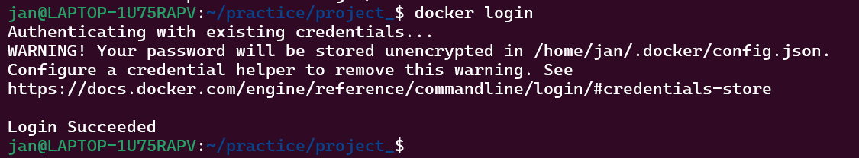

Tagged the Docker Image for Pushing:



Push the Docker Images to Docker Hub (dev and prod repos):

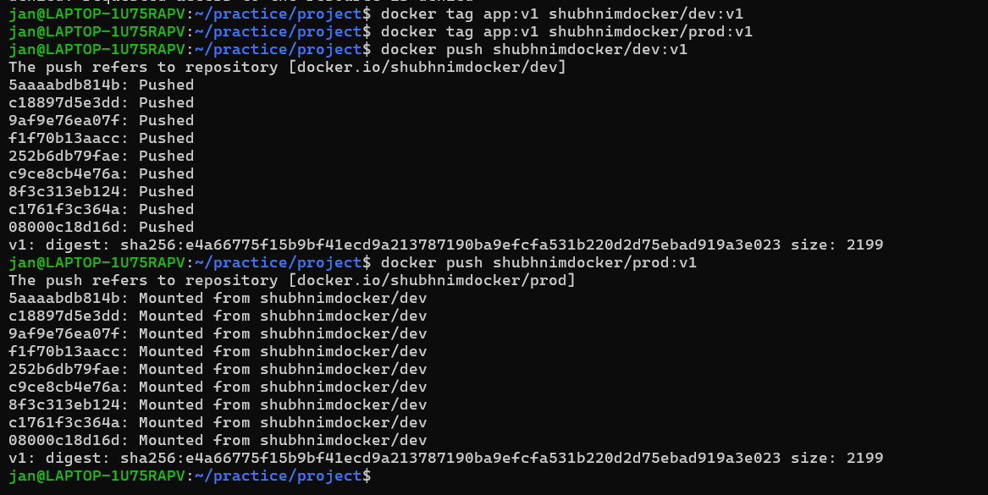

Verified from DockerHub:

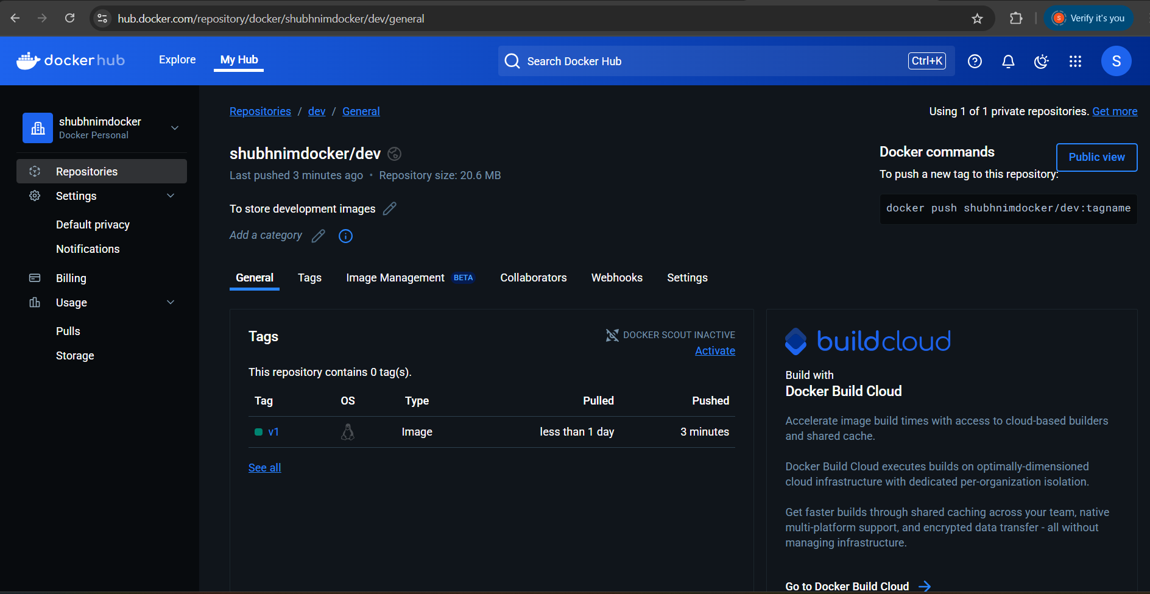

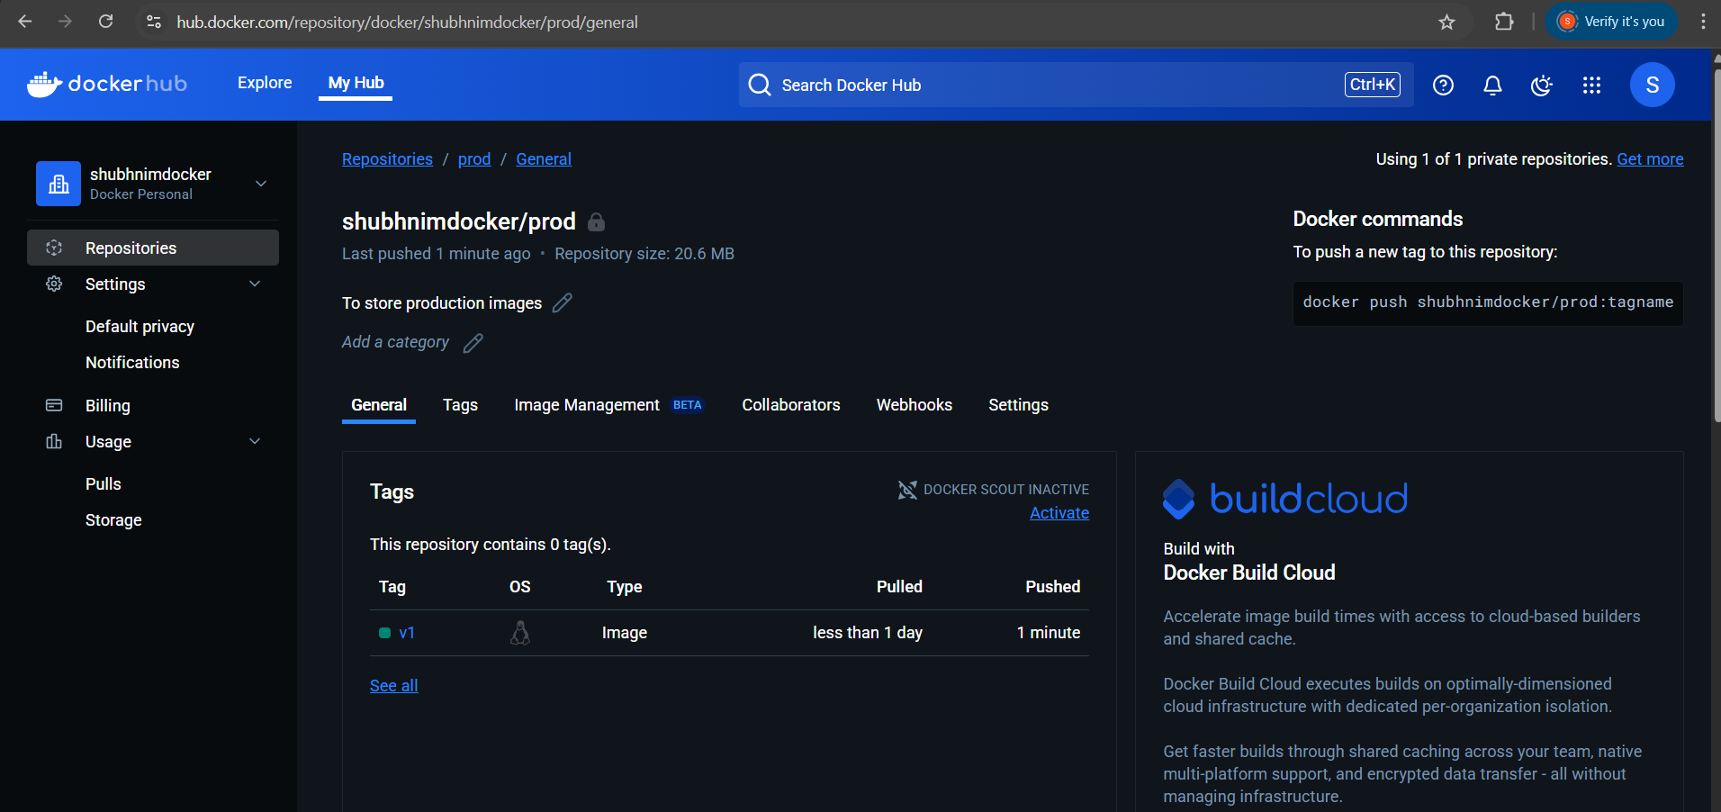

Now I have Docker images stored and tagged in both the **dev** and **prod** repositories.

Install Jenkins on AWS EC2 :

AWS:

Launch the EC2 instance:

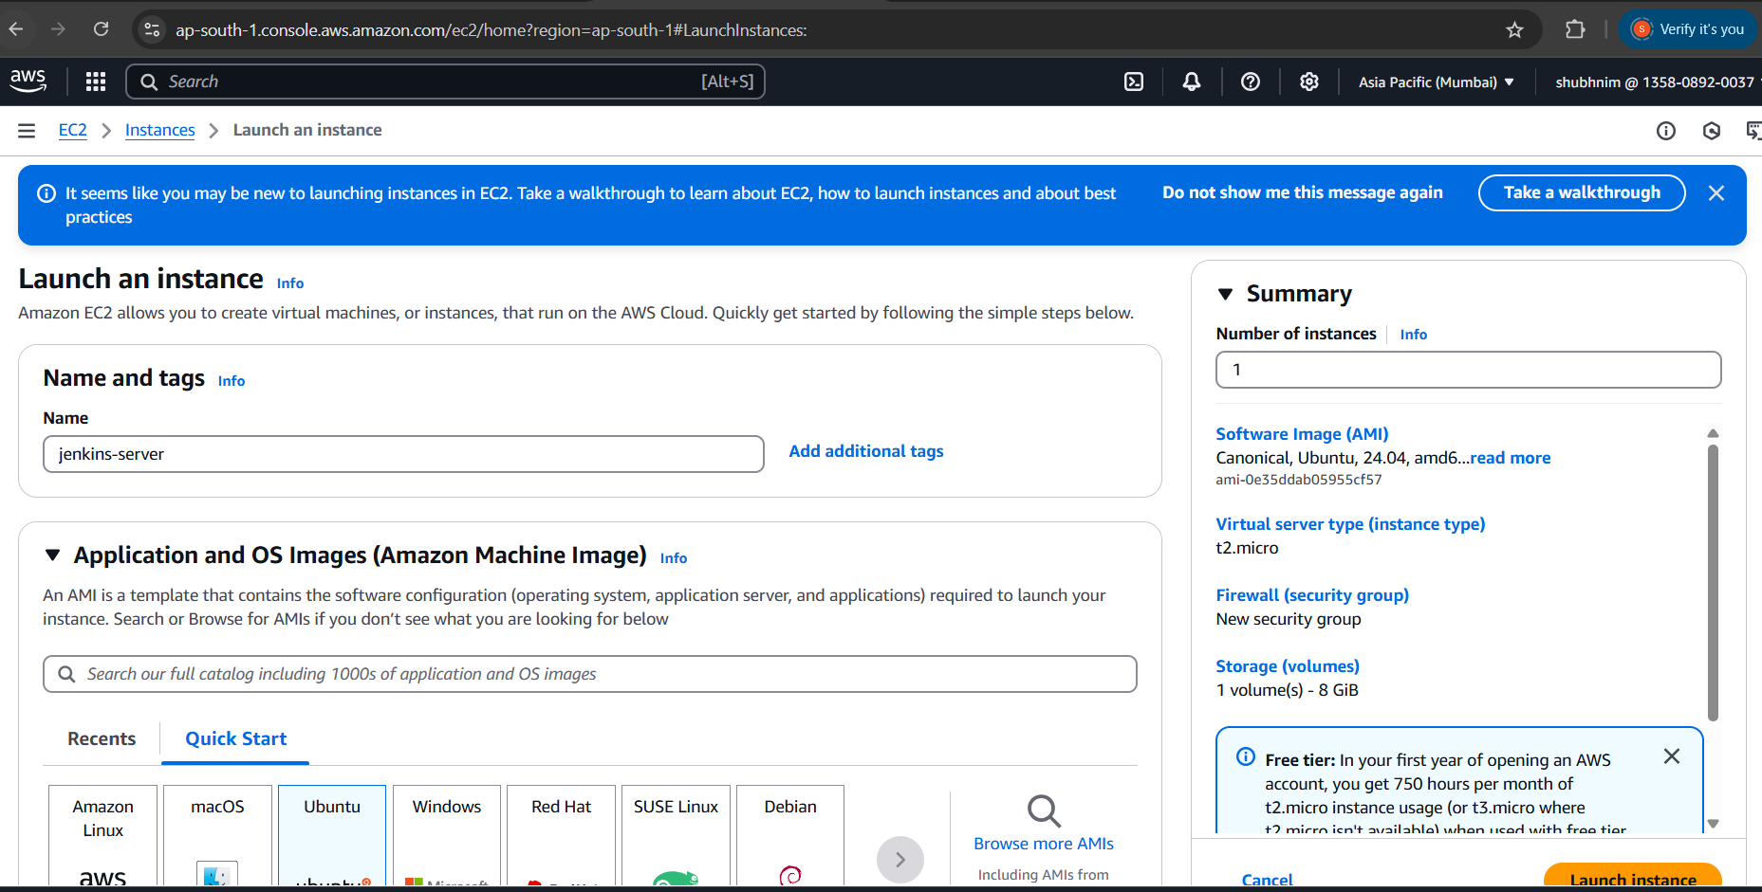

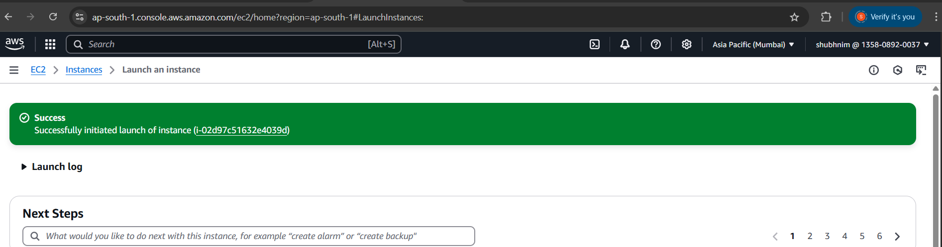

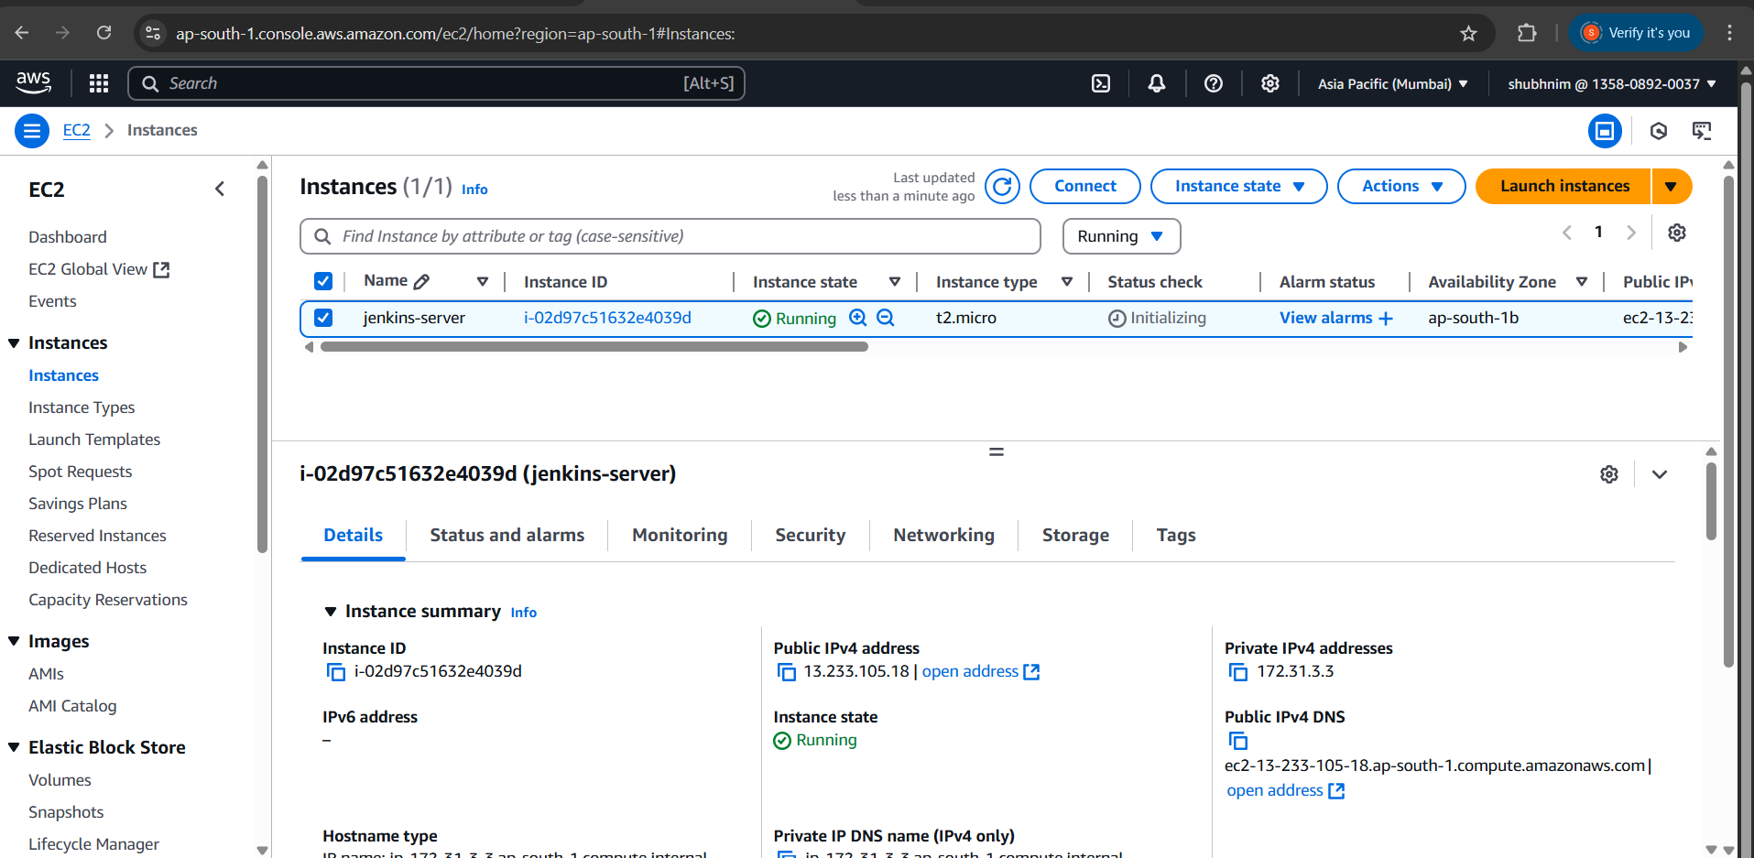

Security Group:

Login to server can should be made only from my ip address. – SSH – Port 22 – from my address only.

HTTP – port 80 – from anywhere – Whoever has the ip address can access the application

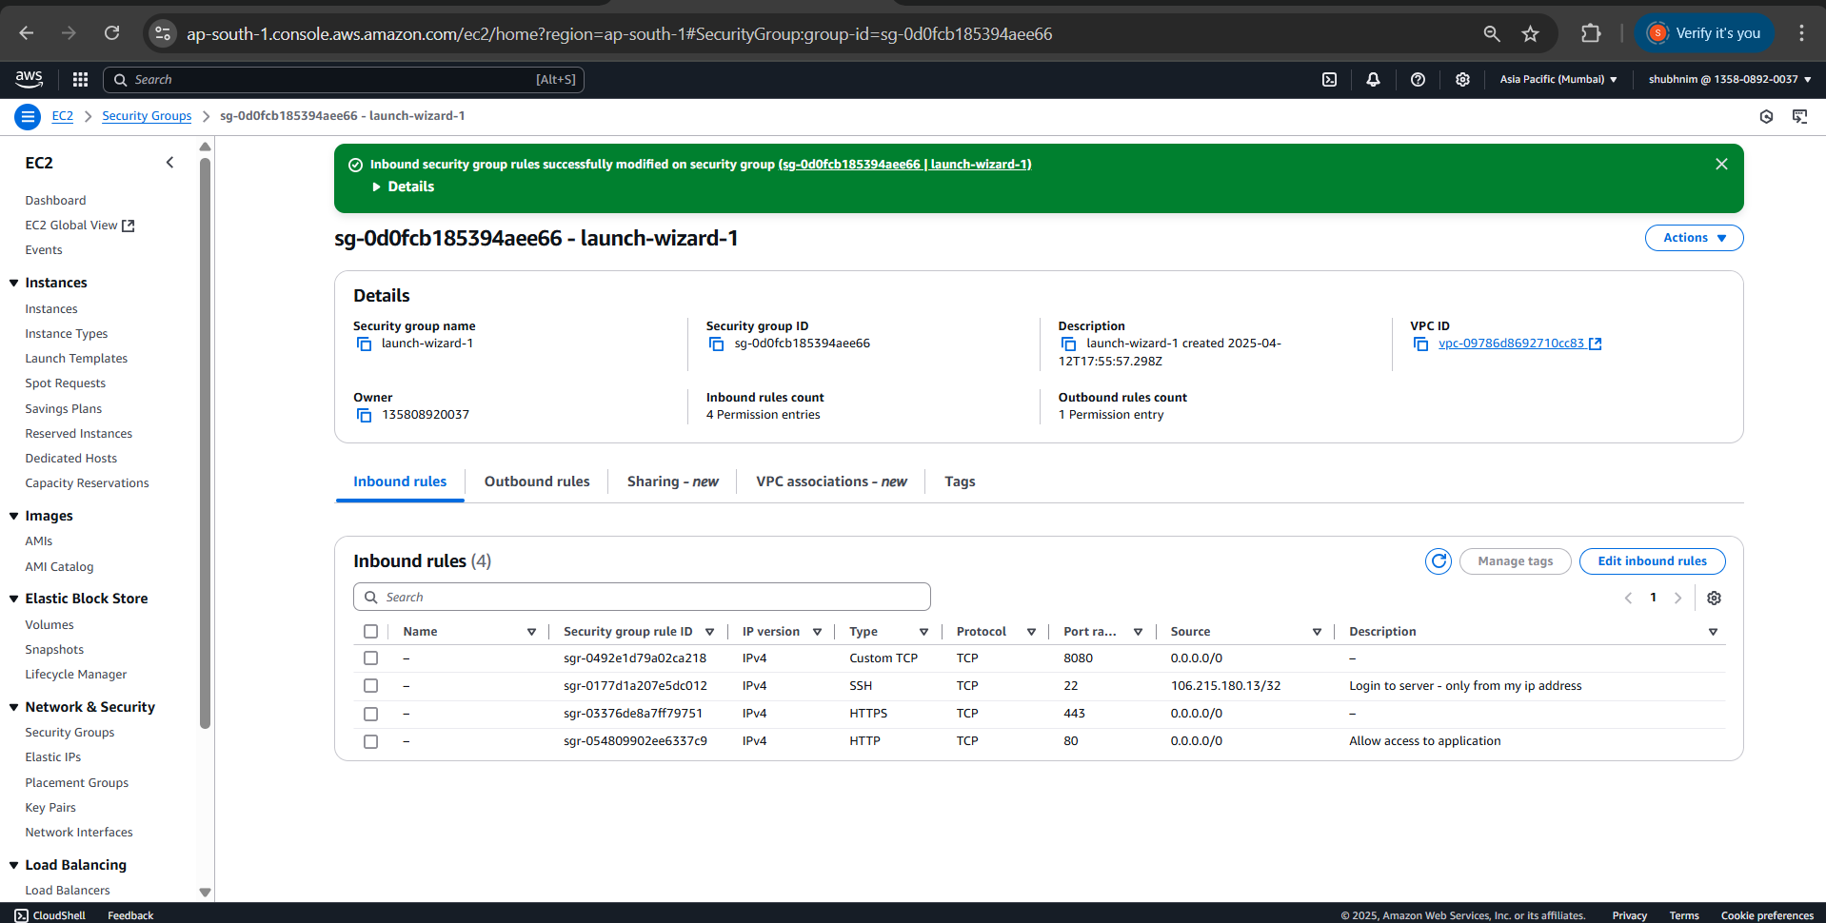

Connect to the EC2 Instance:

Key copied to the path:

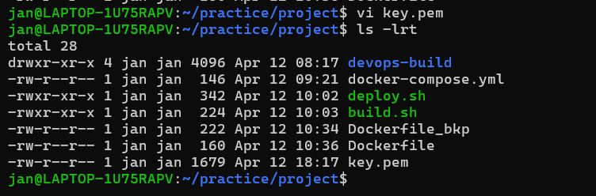

Permission changed to 400 for key.pem file:

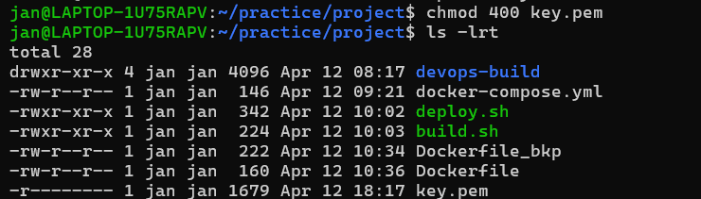

ssh -i key.pem ubuntu@13.233.105.18

connected to the instance :

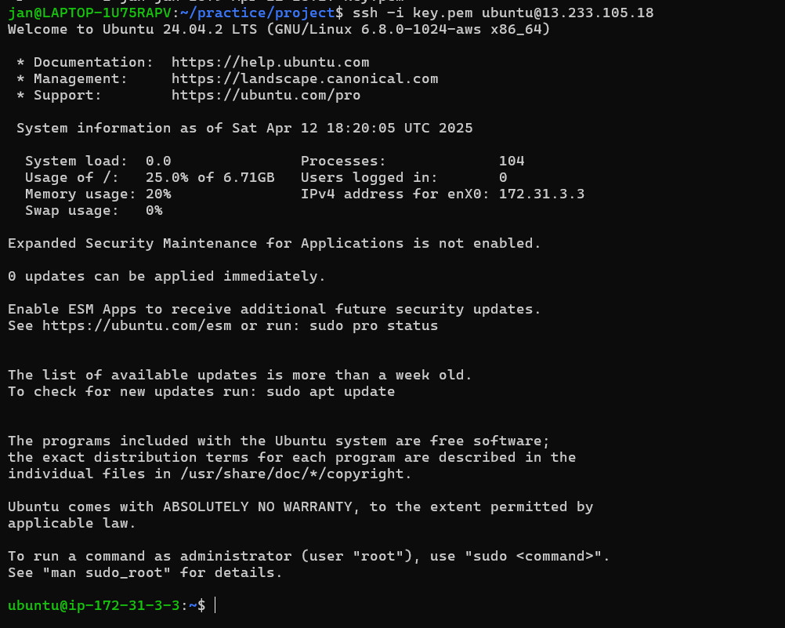

Now installing Jenkins on EC2 instance:

# Update and install dependencies

sudo apt update

sudo apt install -y openjdk-17-jdk curl gnupg2

# Add Jenkins repo

curl -fsSL https://pkg.jenkins.io/debian-stable/jenkins.io-2023.key | sudo tee \

/usr/share/keyrings/jenkins-keyring.asc > /dev/null

echo deb [signed-by=/usr/share/keyrings/jenkins-keyring.asc] \

https://pkg.jenkins.io/debian-stable binary/ | sudo tee \

/etc/apt/sources.list.d/jenkins.list > /dev/null

# Install Jenkins

sudo apt update

sudo apt install -y Jenkins

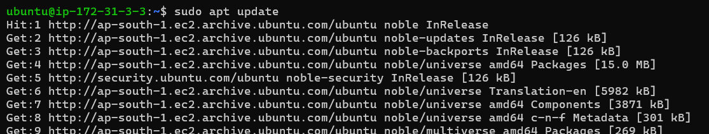

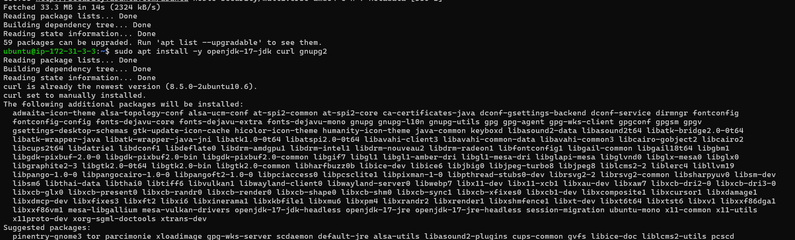

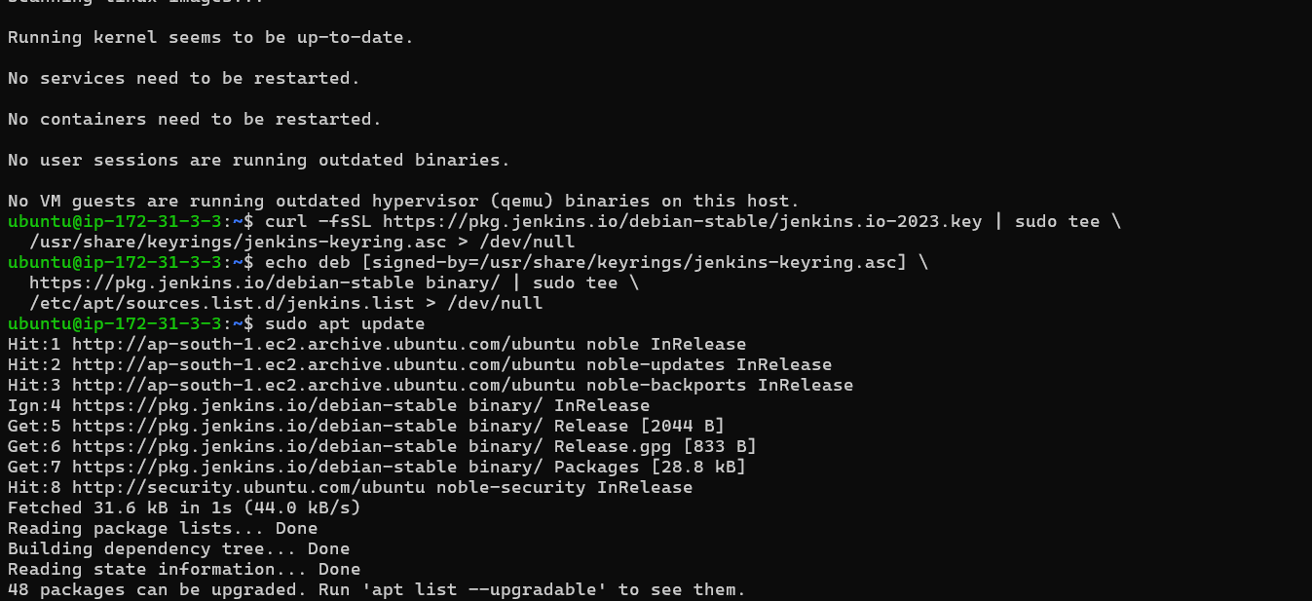

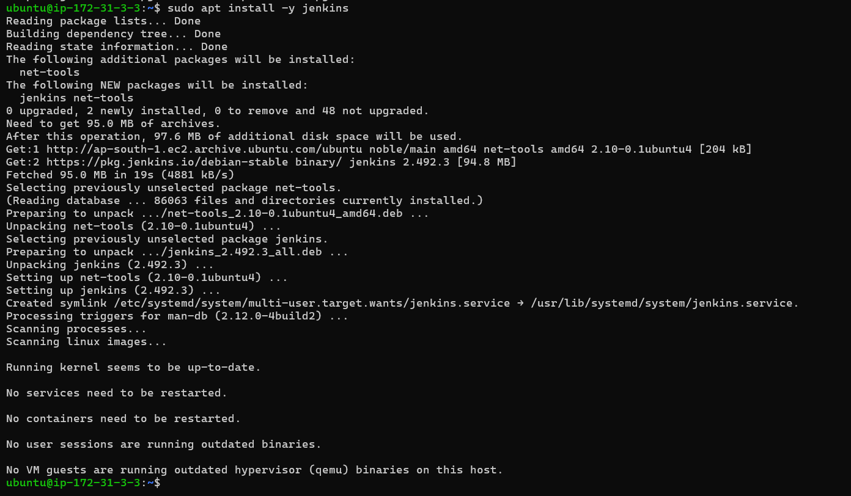

Start Jenkins:

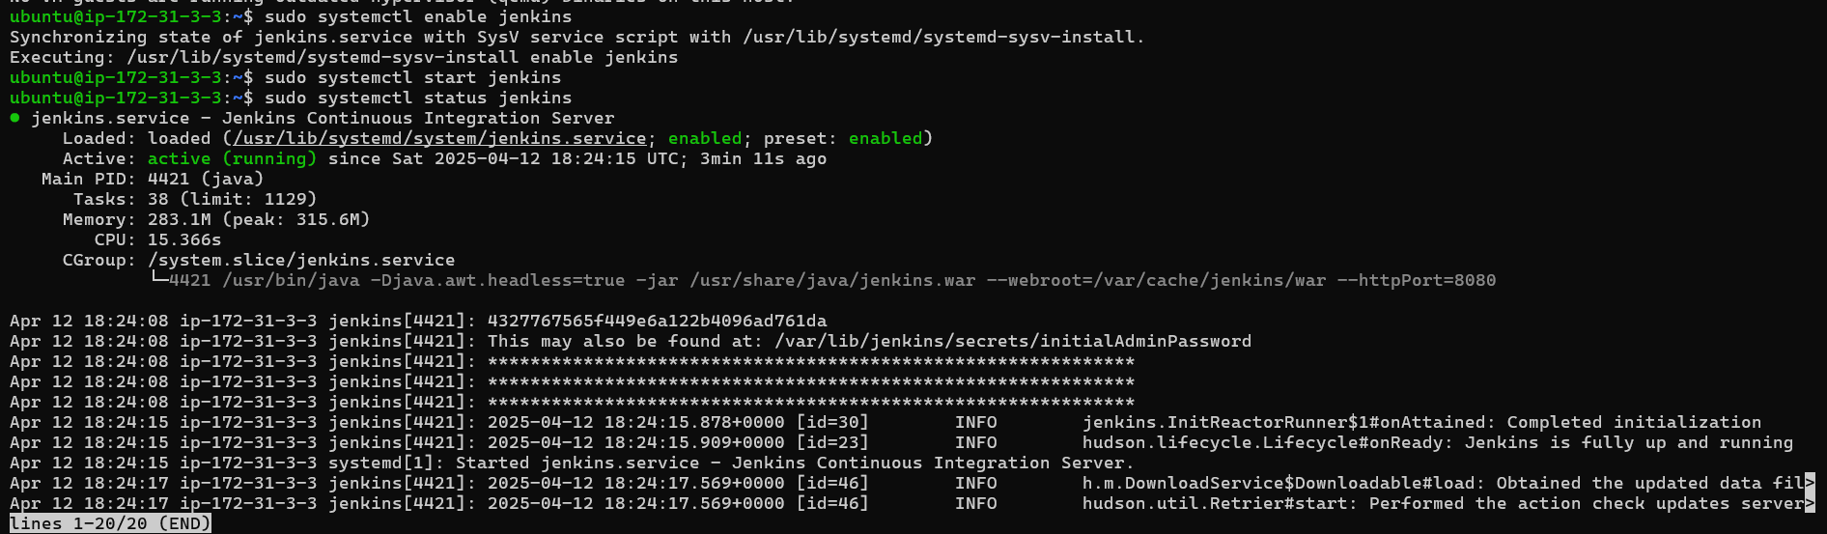

Accessing Jenkins UI:

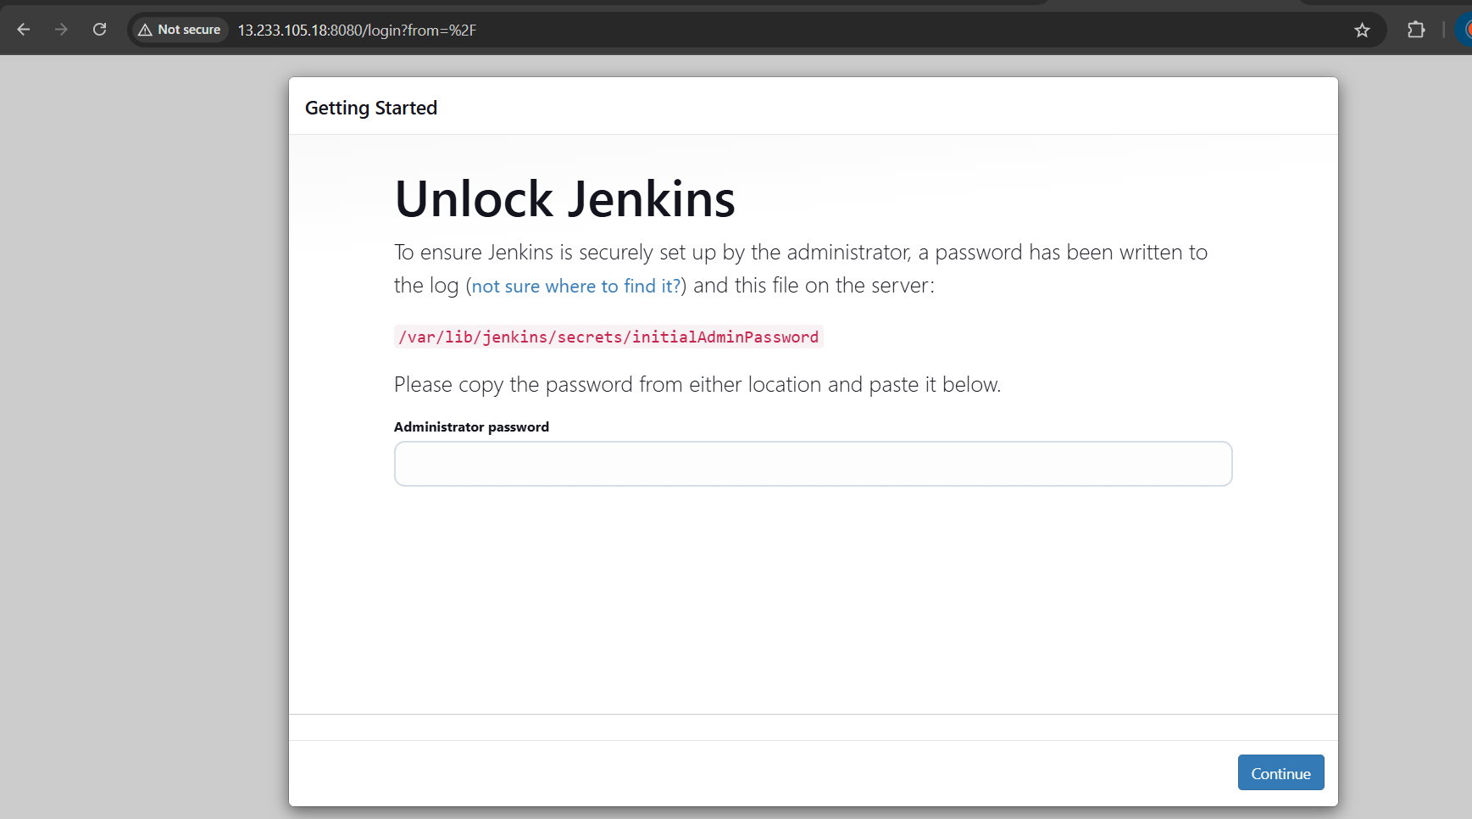



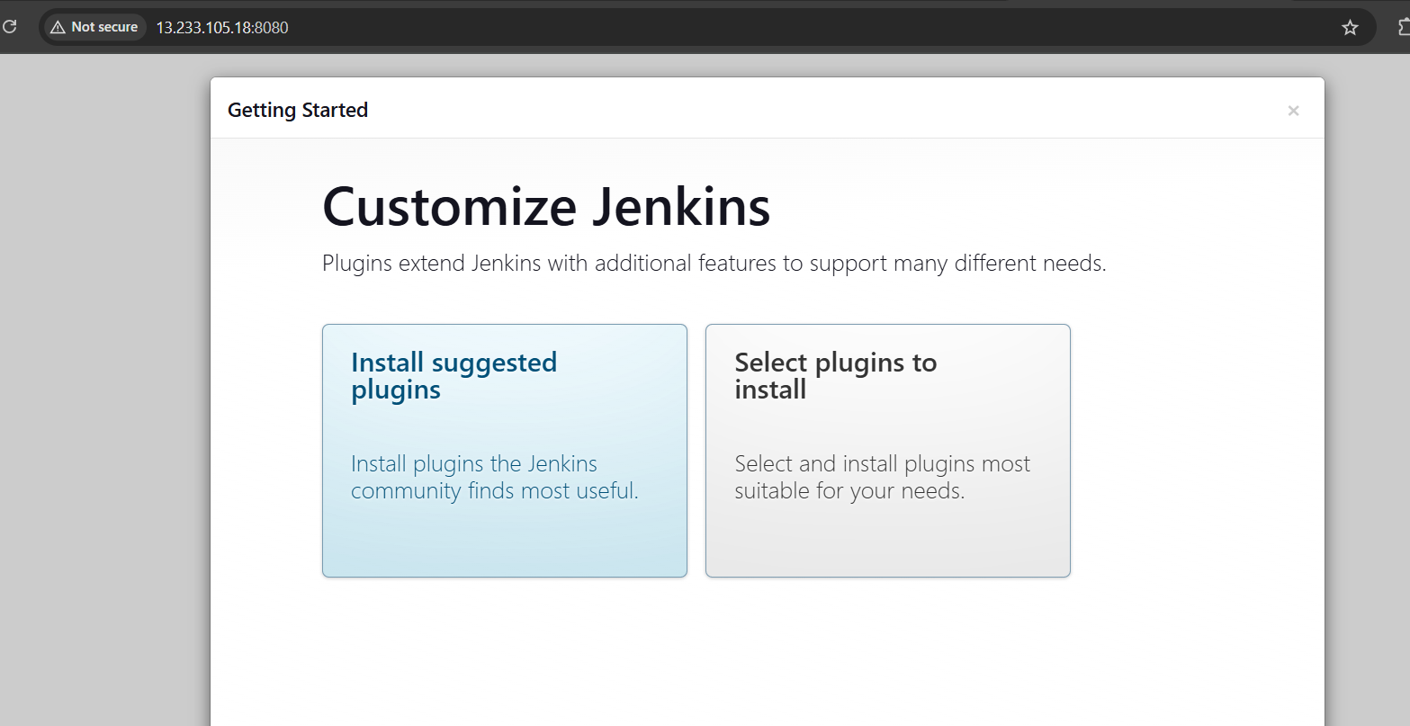

Install suggested plugins:

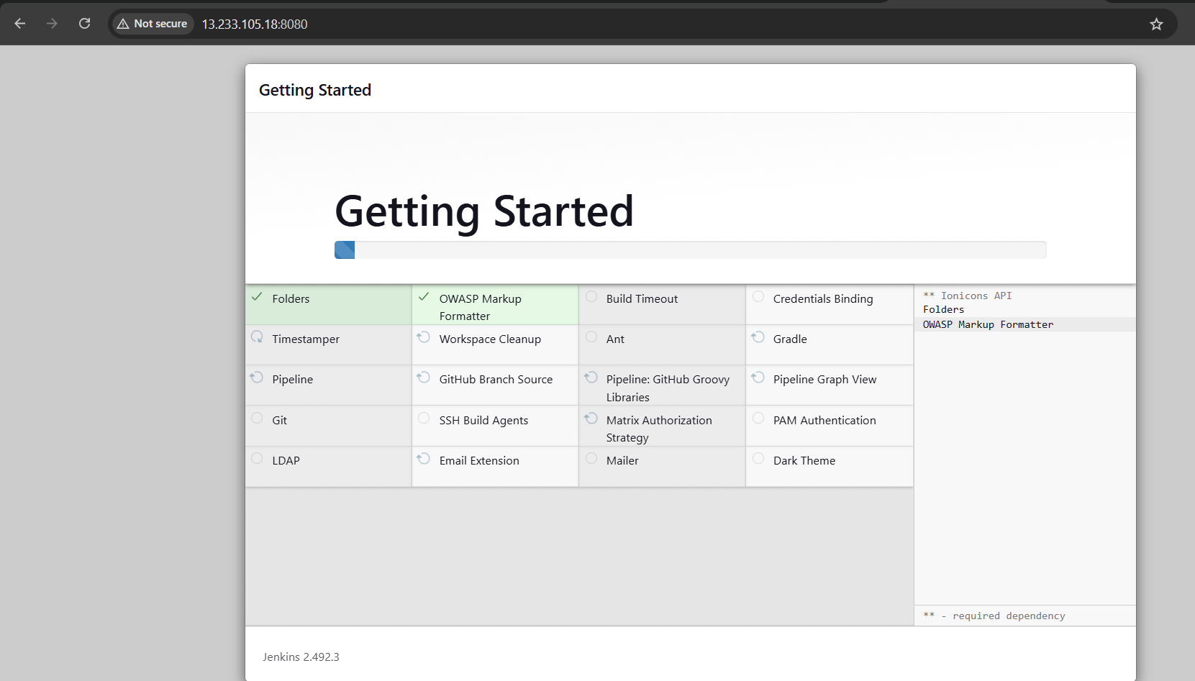

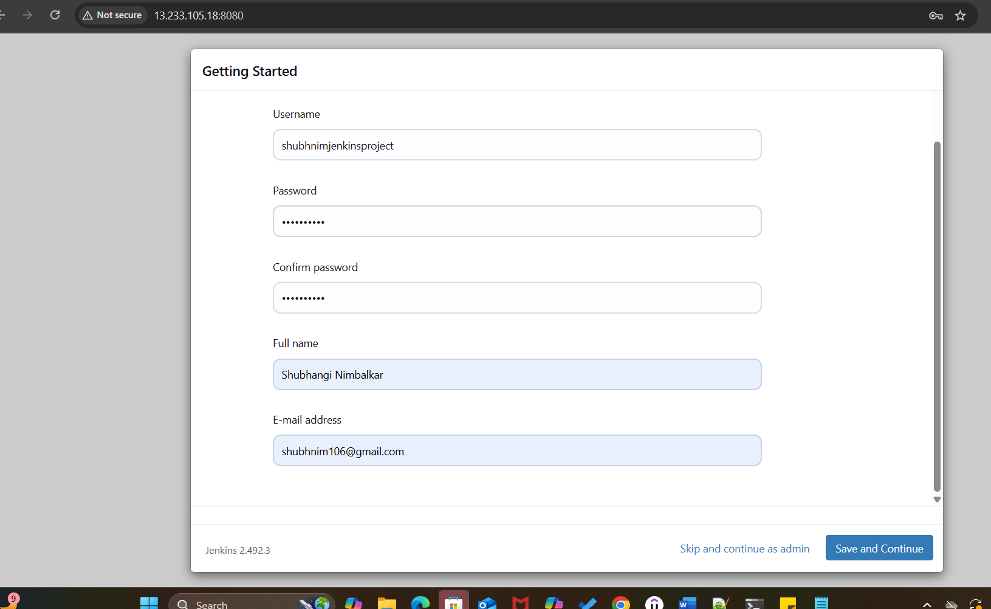

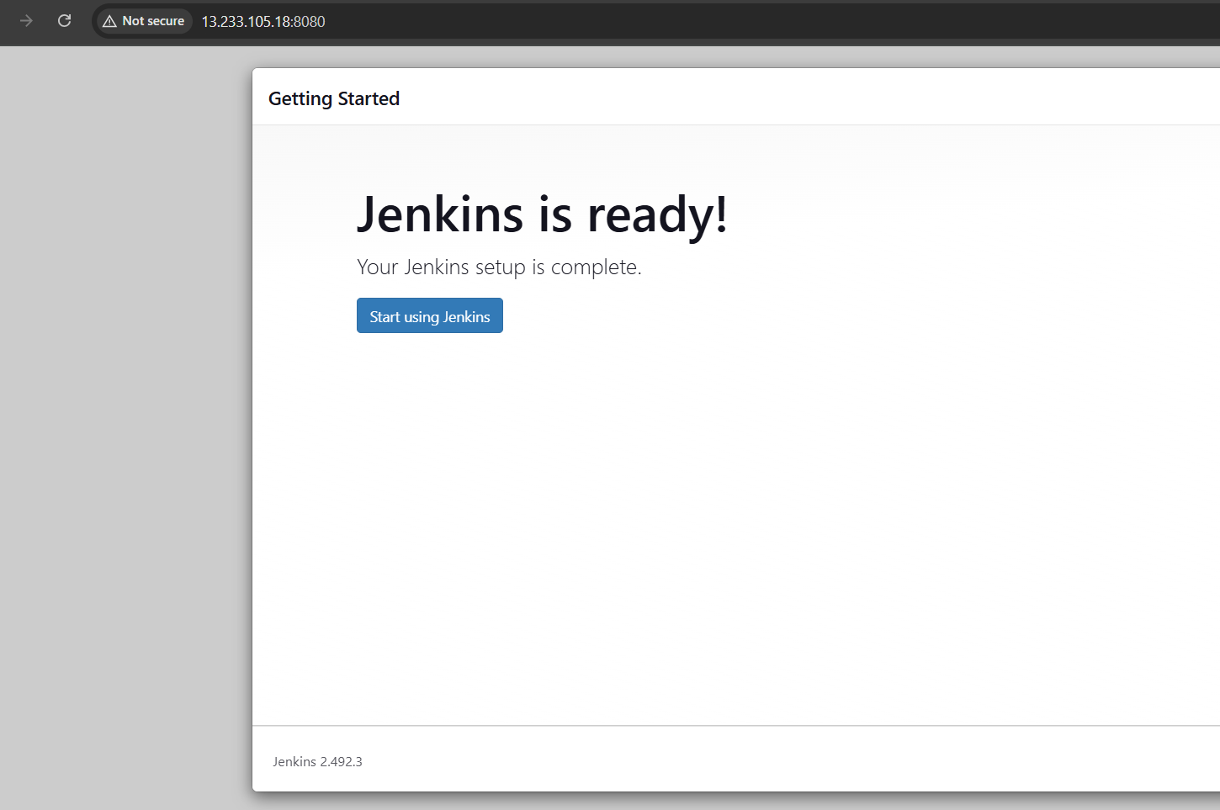

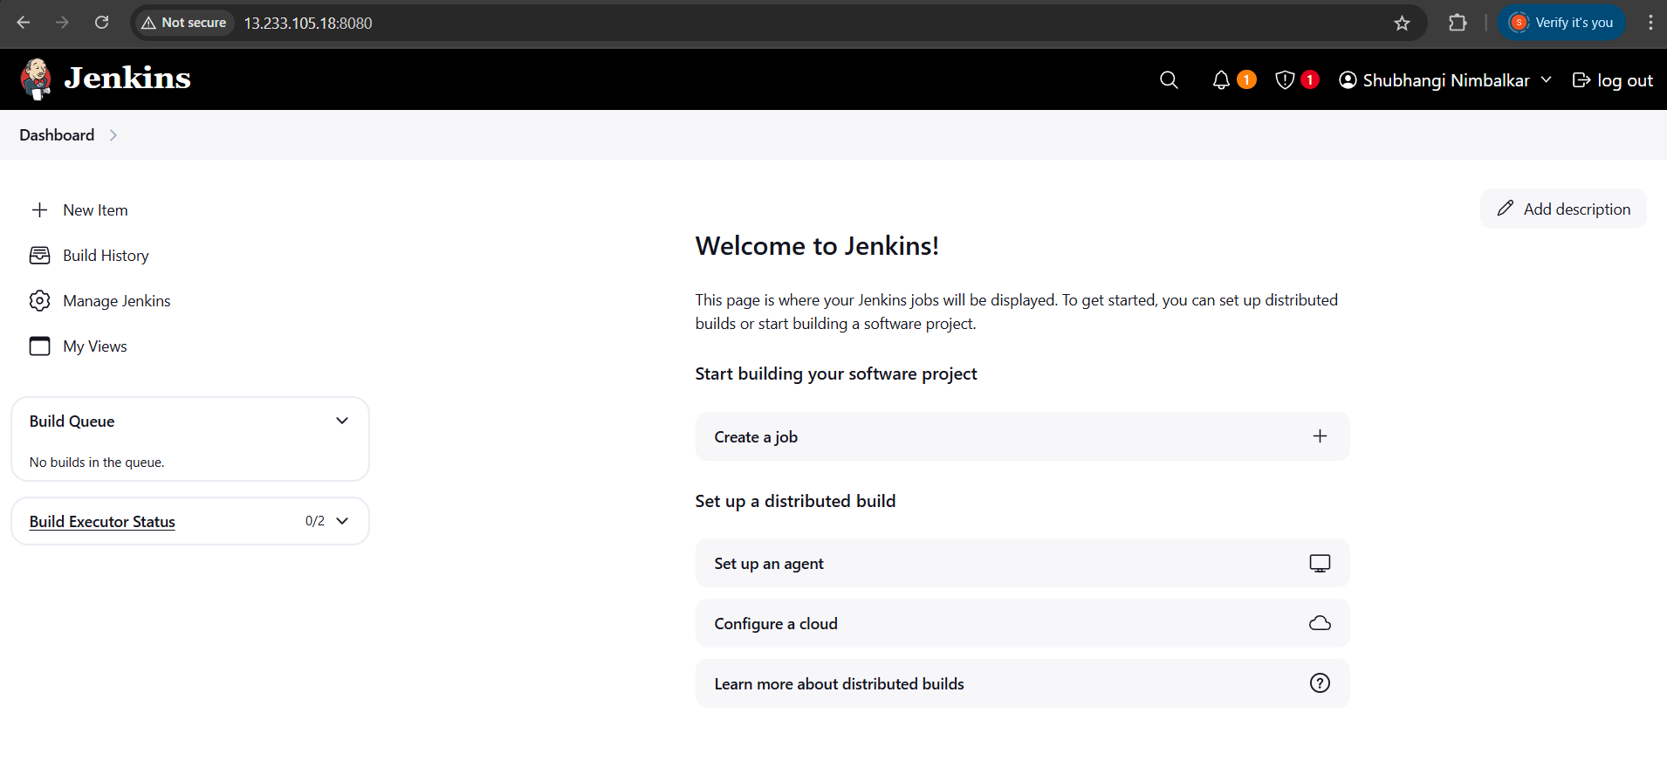

Install Docker on the EC2 instance:

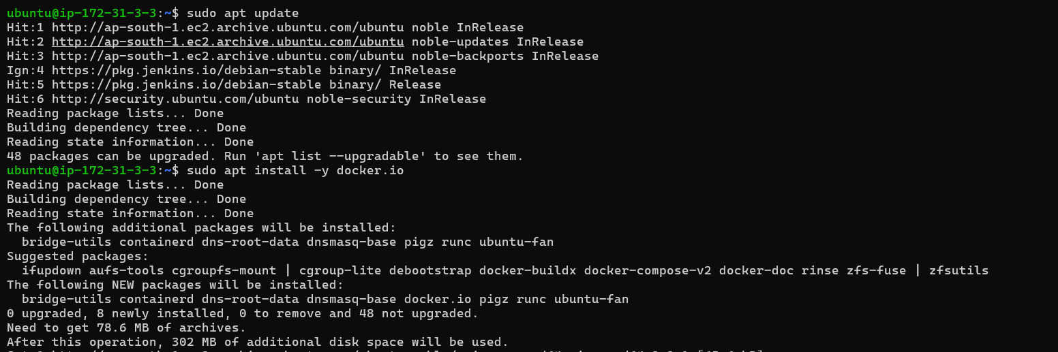

Started docker:

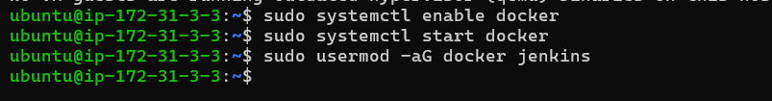

Now installed Jenkins Plugins:

Docker Pipeline:

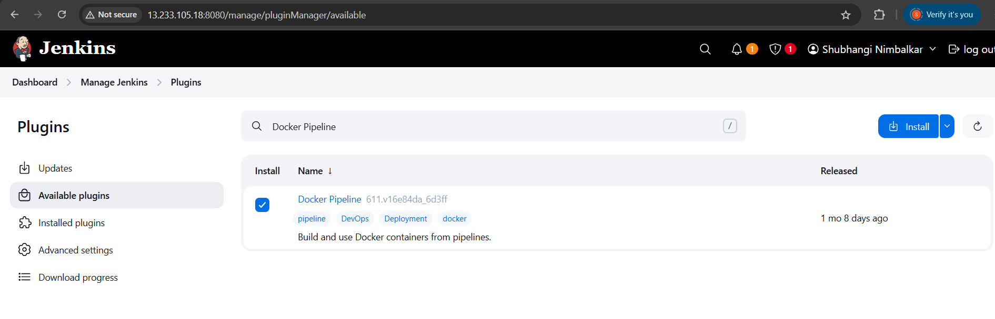

Github integration:

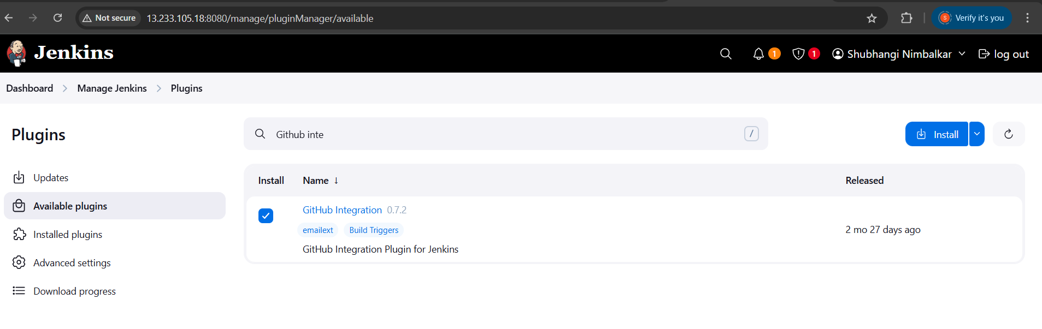

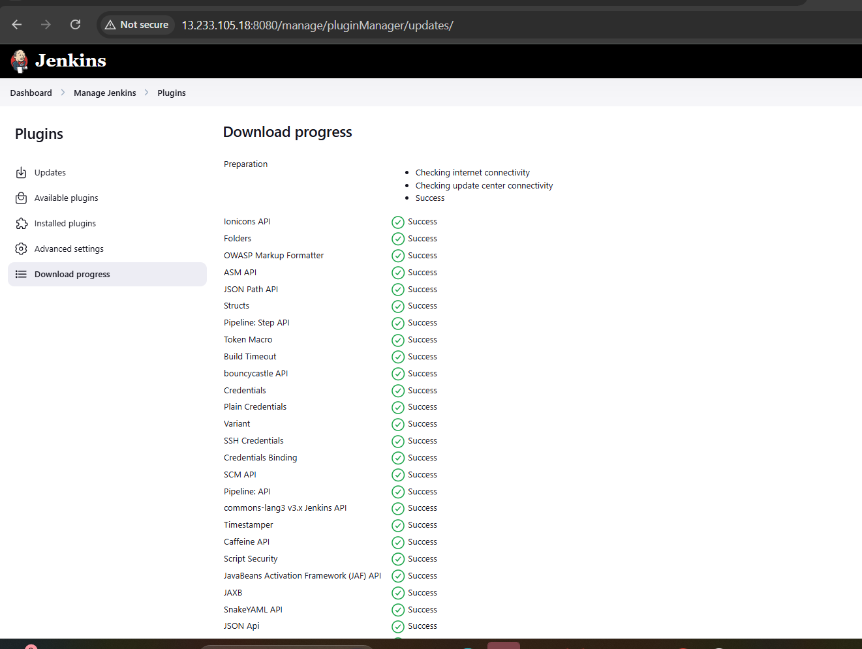

Restarted Jenkins to apply changes:

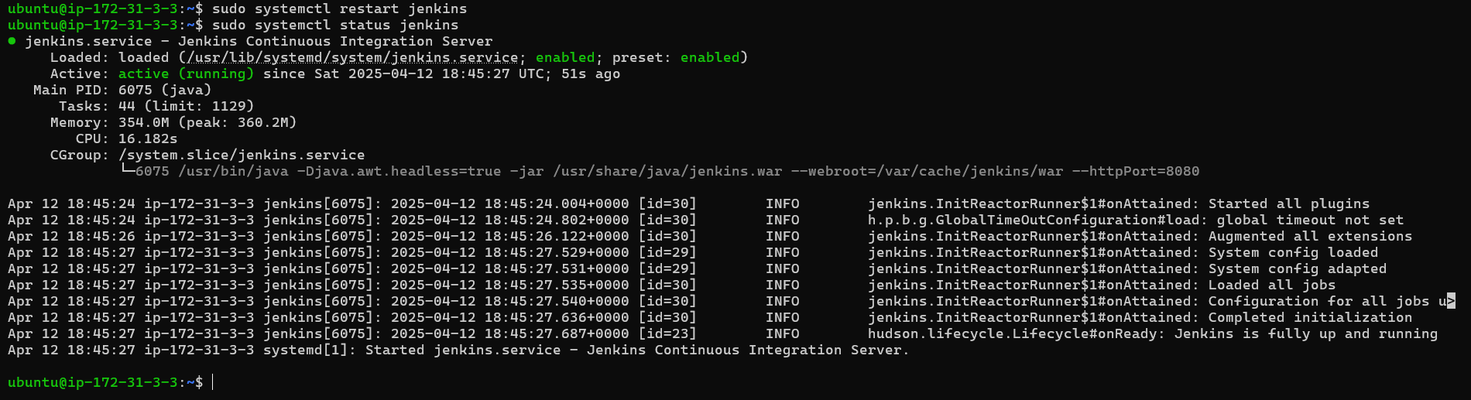

Writing the Jenkins Pipeline (Jenkinsfile)

automation steps for:

* Cloning GitHub repo
* Building the Docker image
* Tagging and pushing to DockerHub (dev/prod based on the branch)

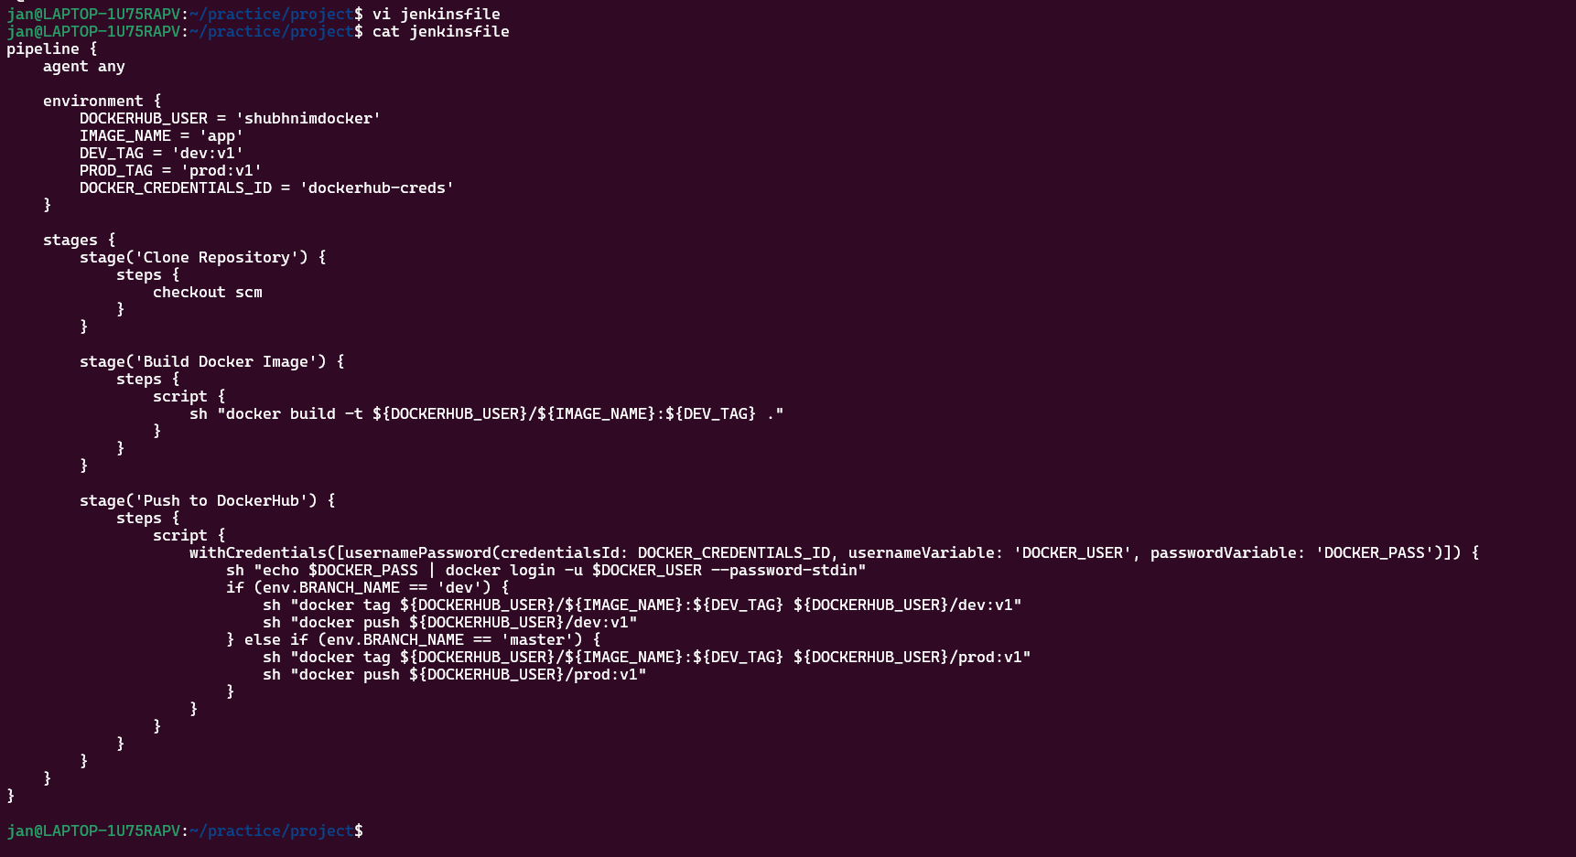

Added DockerHub credentials in Jenkins:

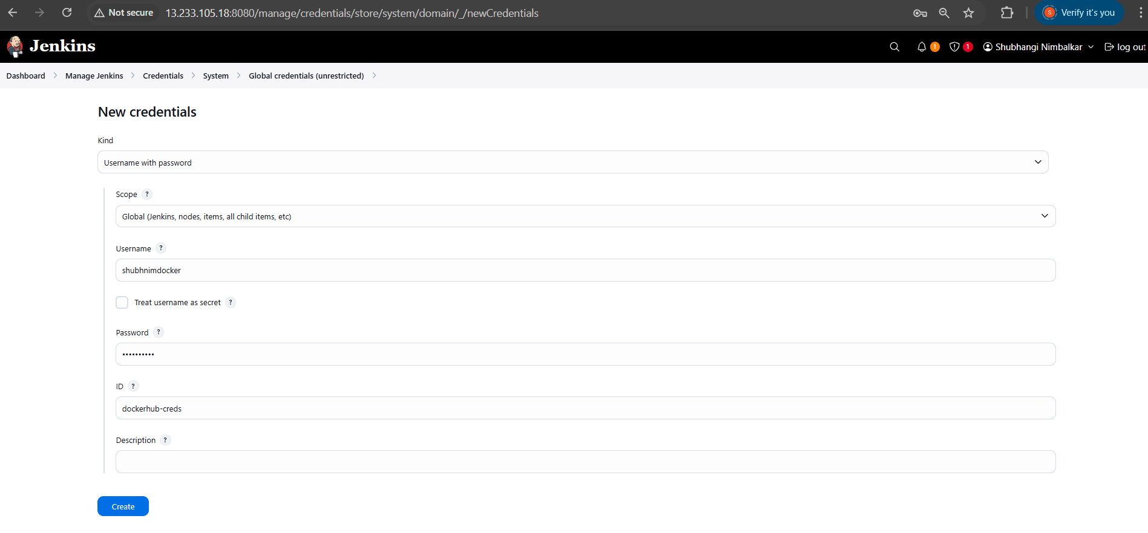

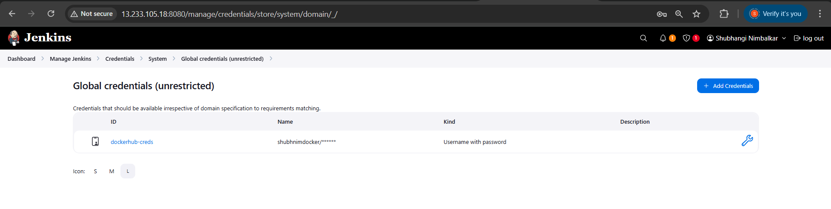

Configuring GitHub Webhook:

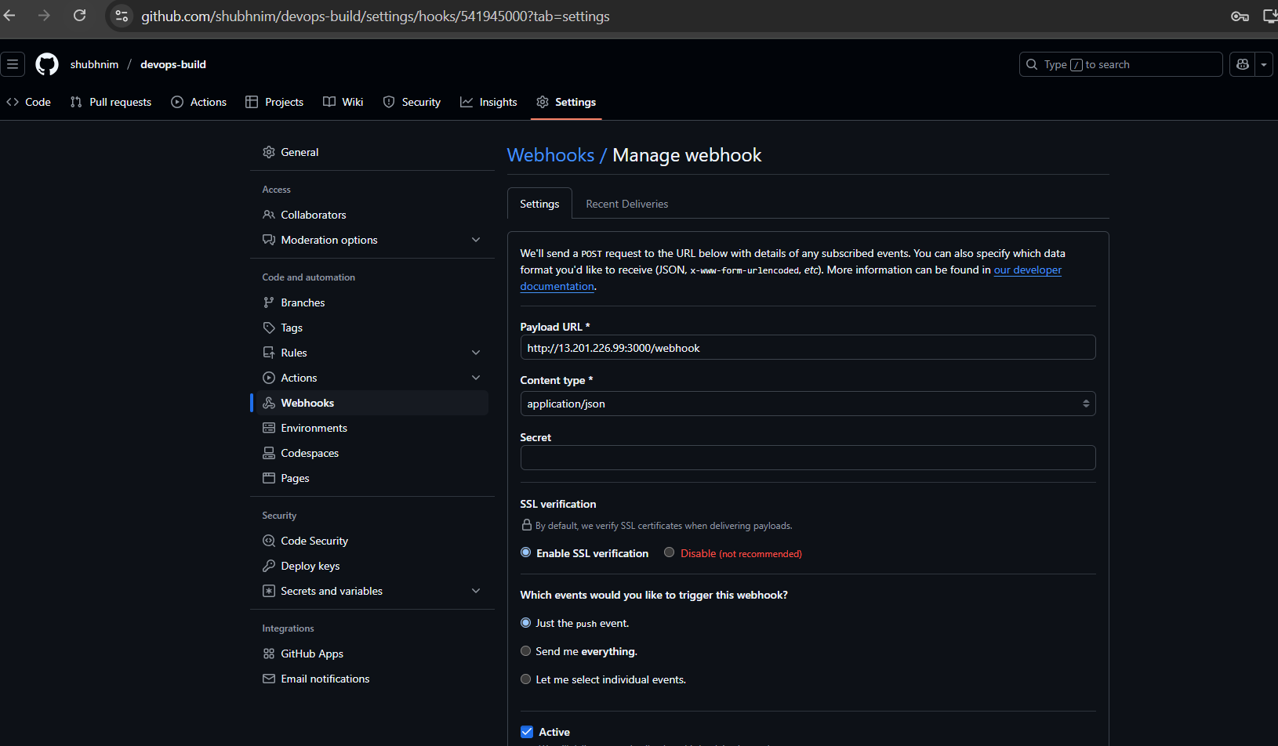

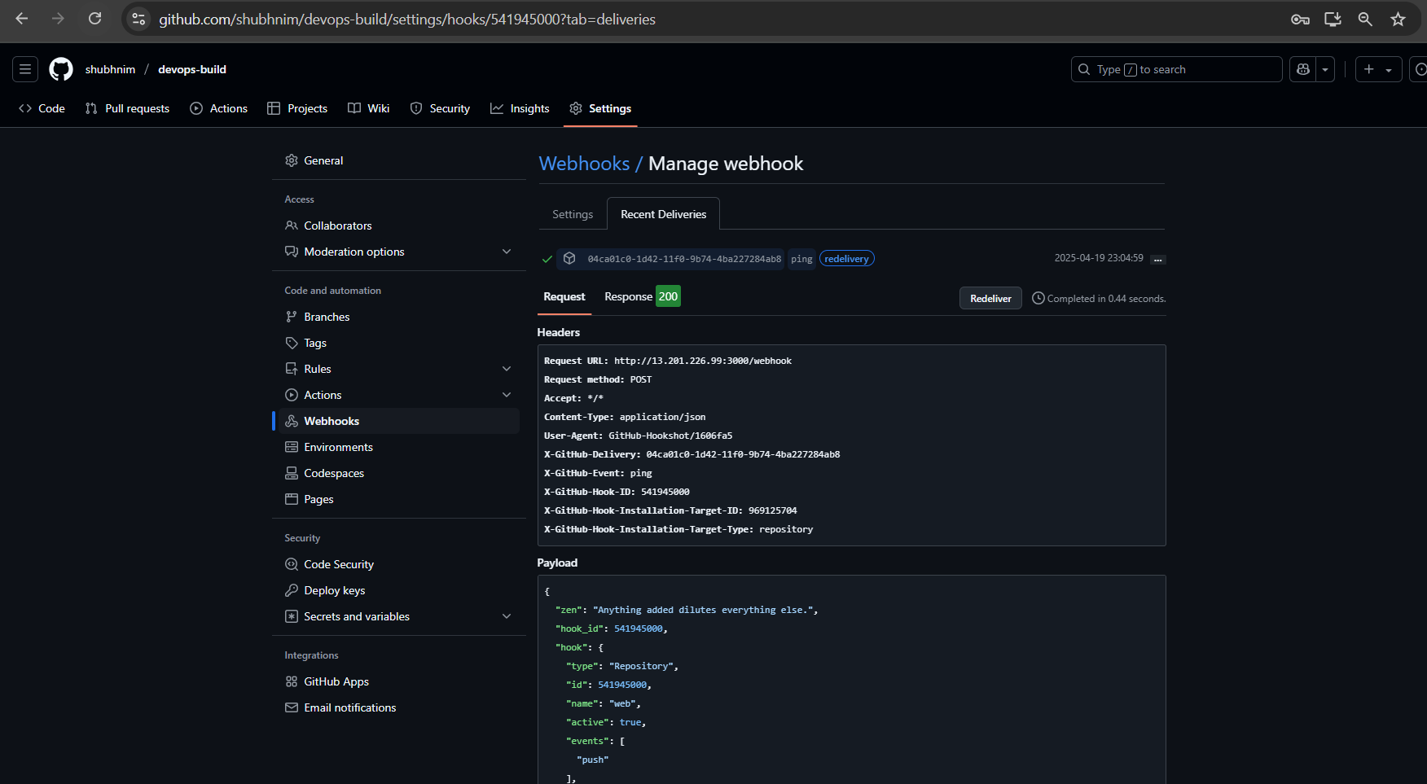

Created a Multibranch Pipeline Job:

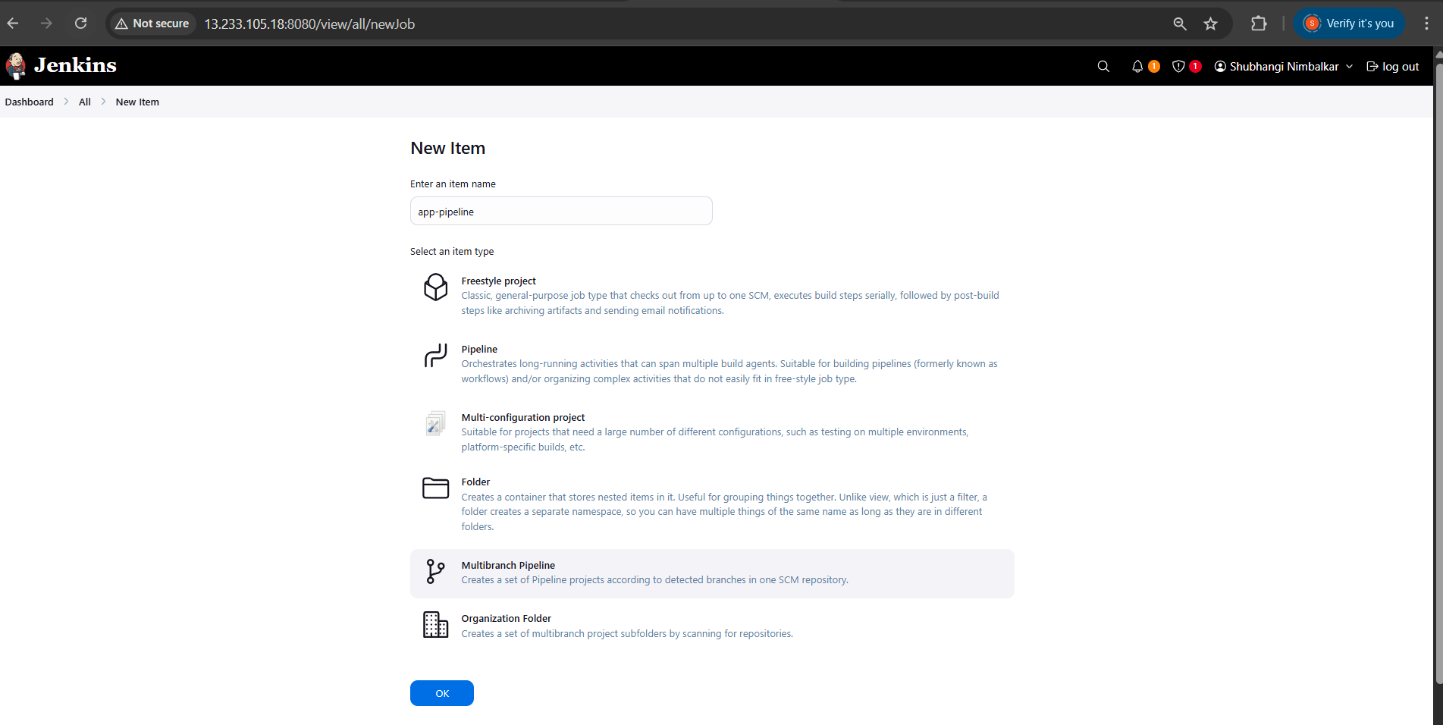

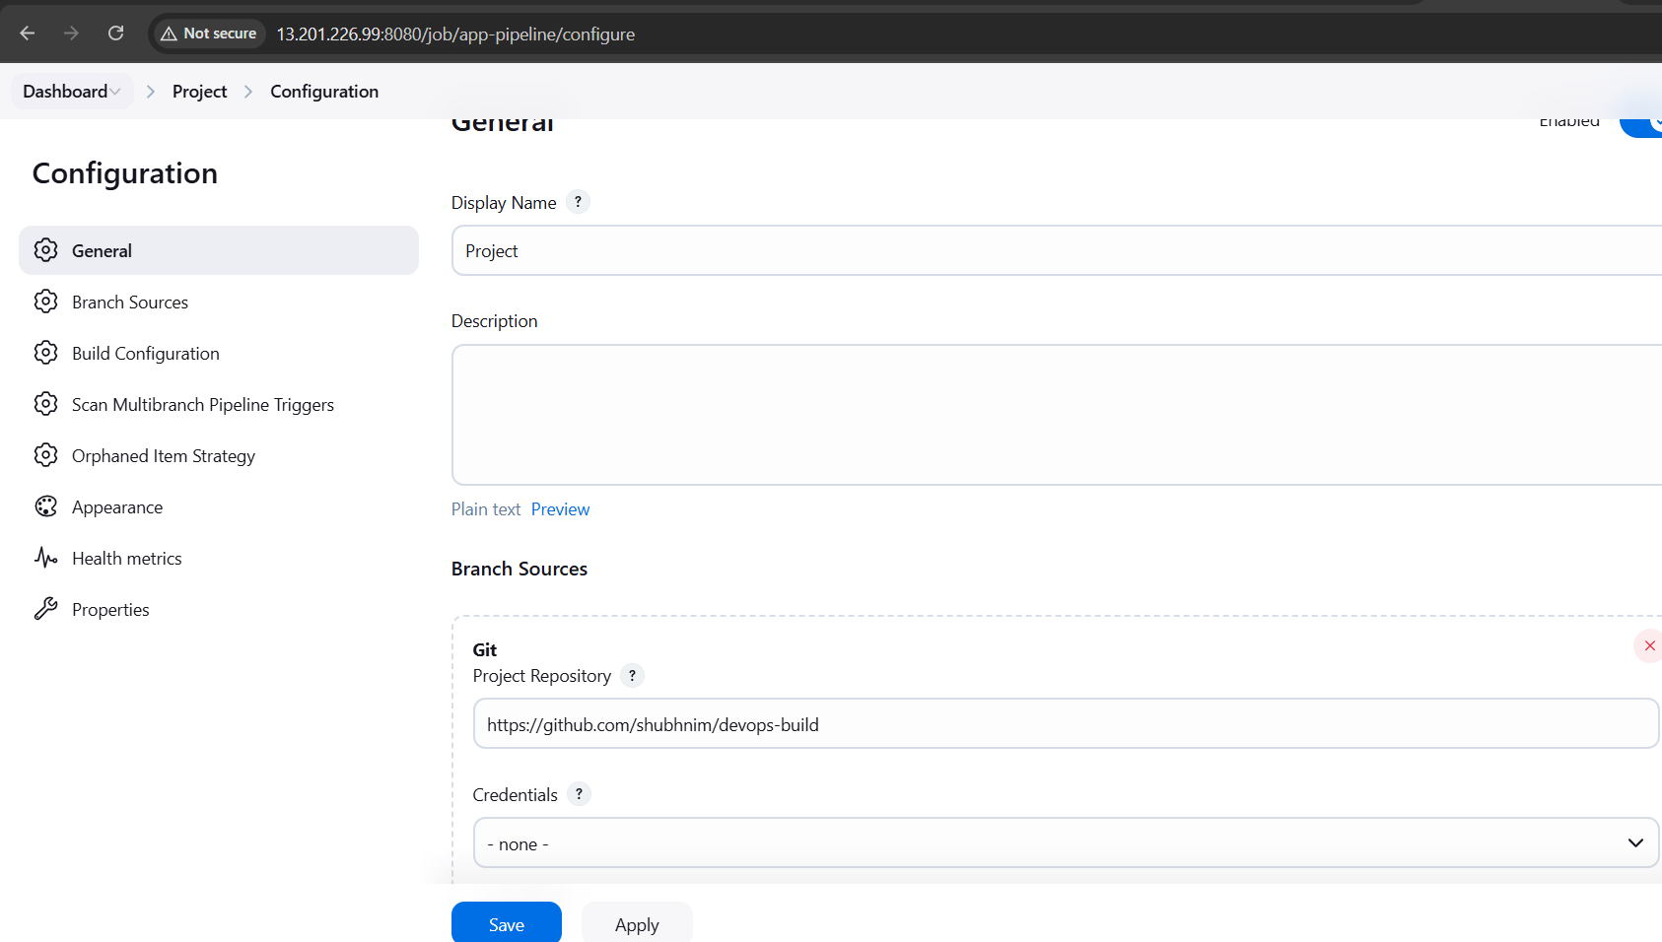

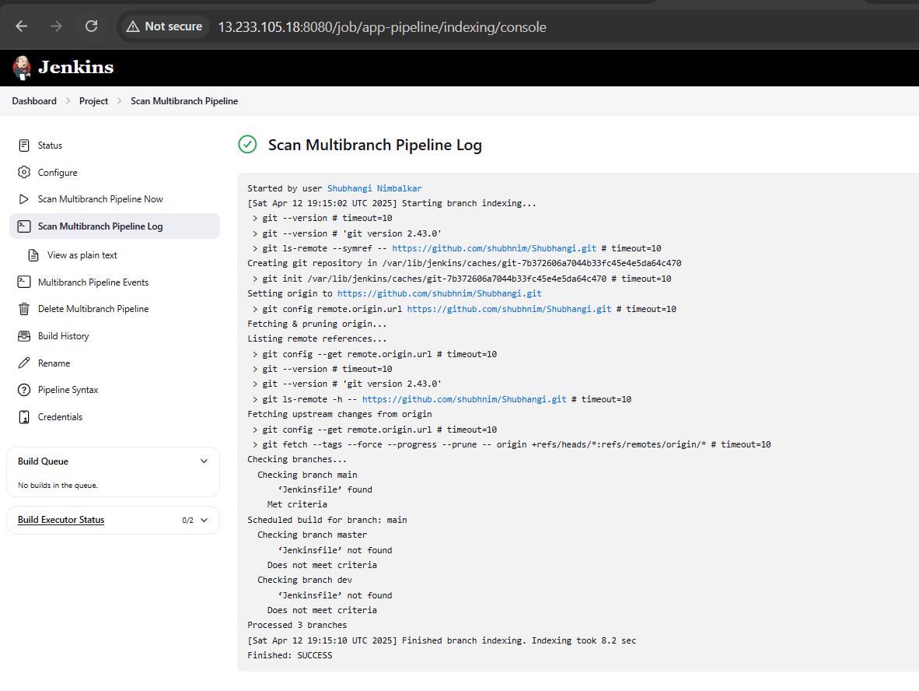

It could not find jenkinesfile.

To make Jenkins read the Jenkinsfile from GitHub, I need to push the latest local changes (which include the new Jenkinsfile) to my GitHub repo.

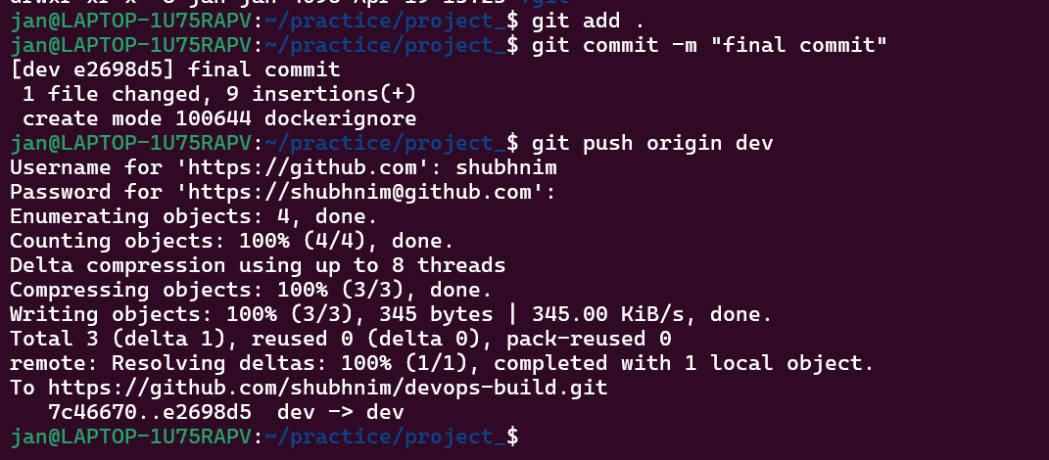

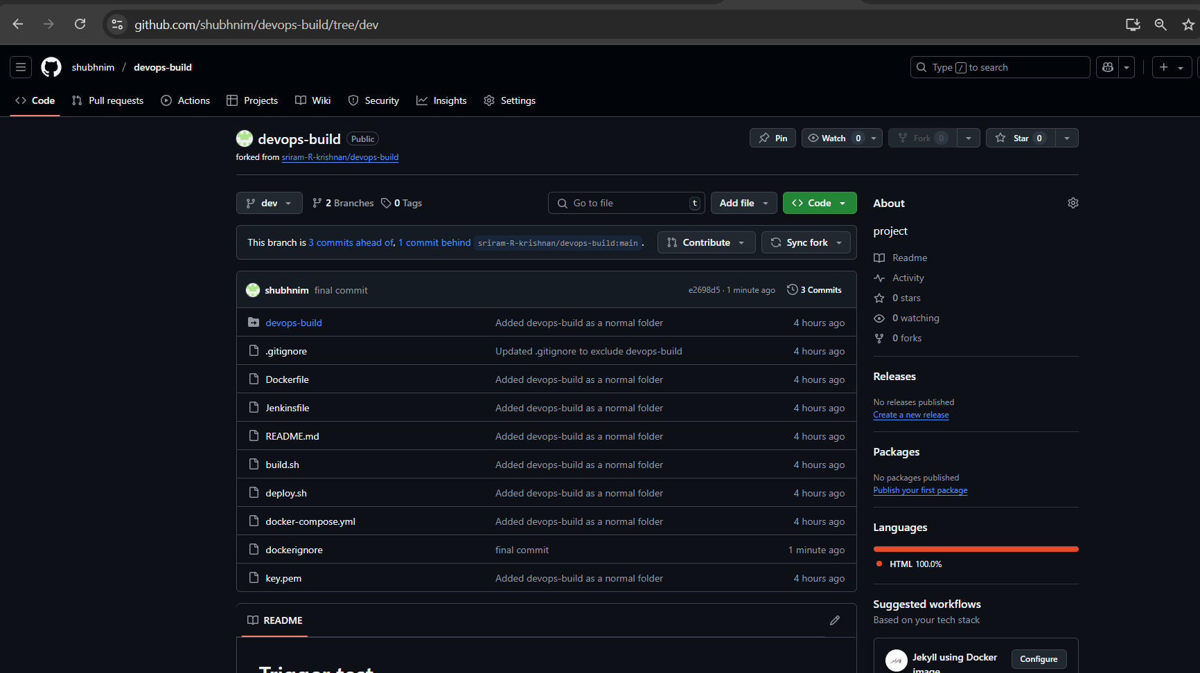

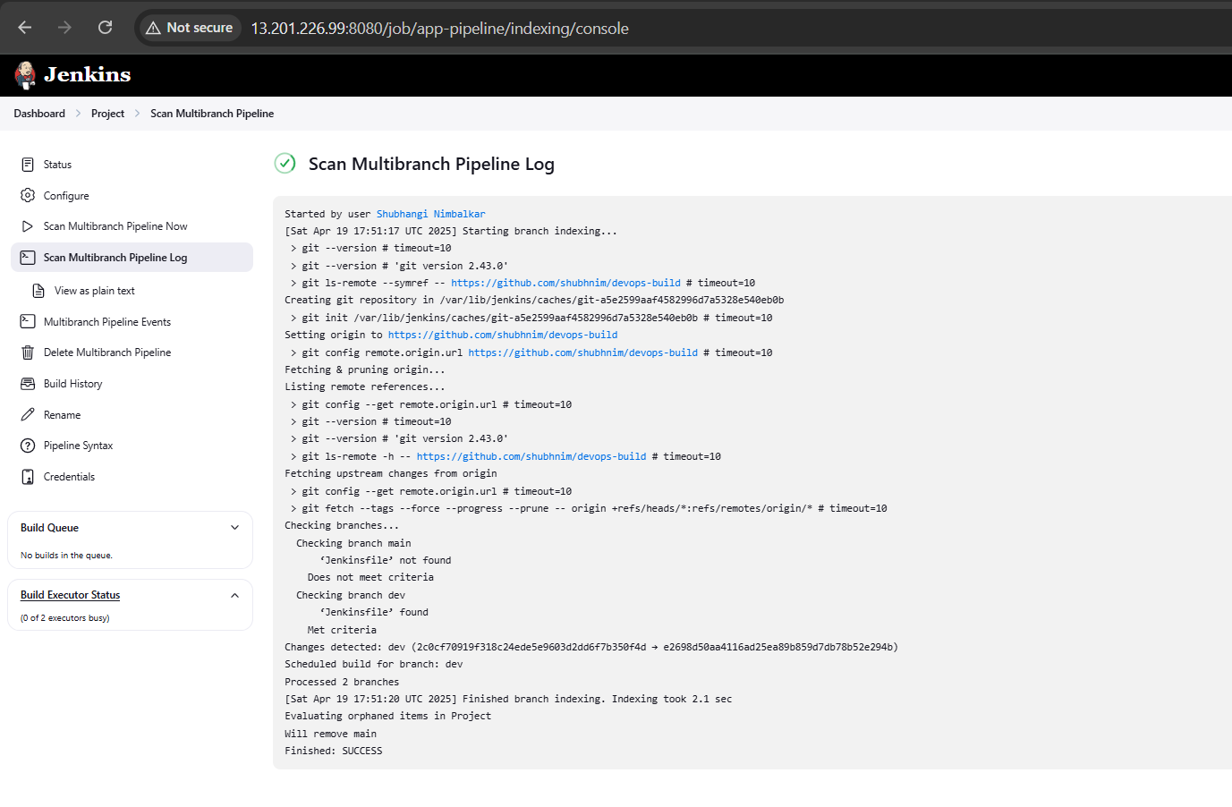

code was pushed to dev branch, docker image built and pushed to dev repo in docker hub:

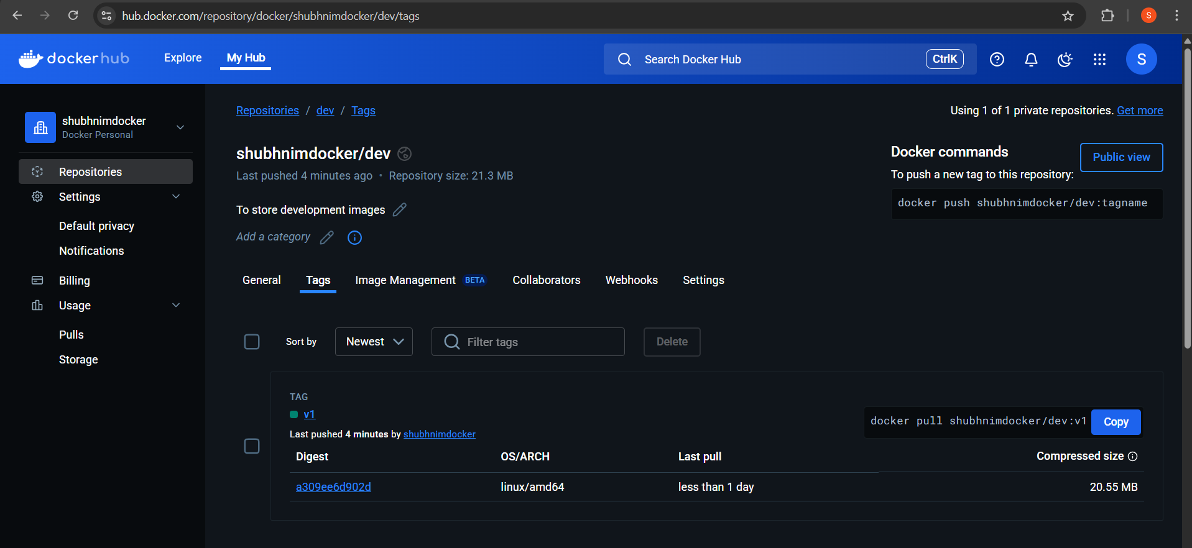

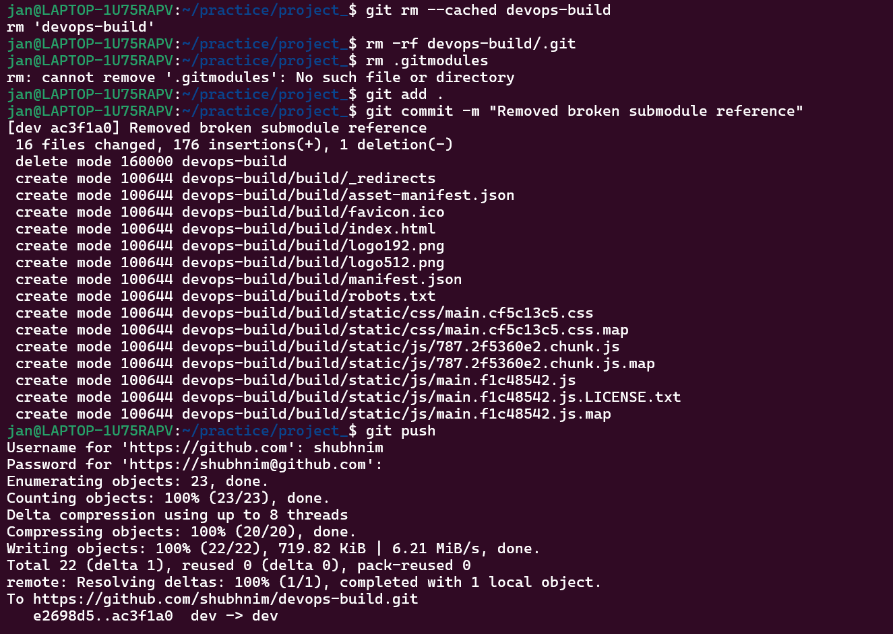

Jenkins build succeeded:  
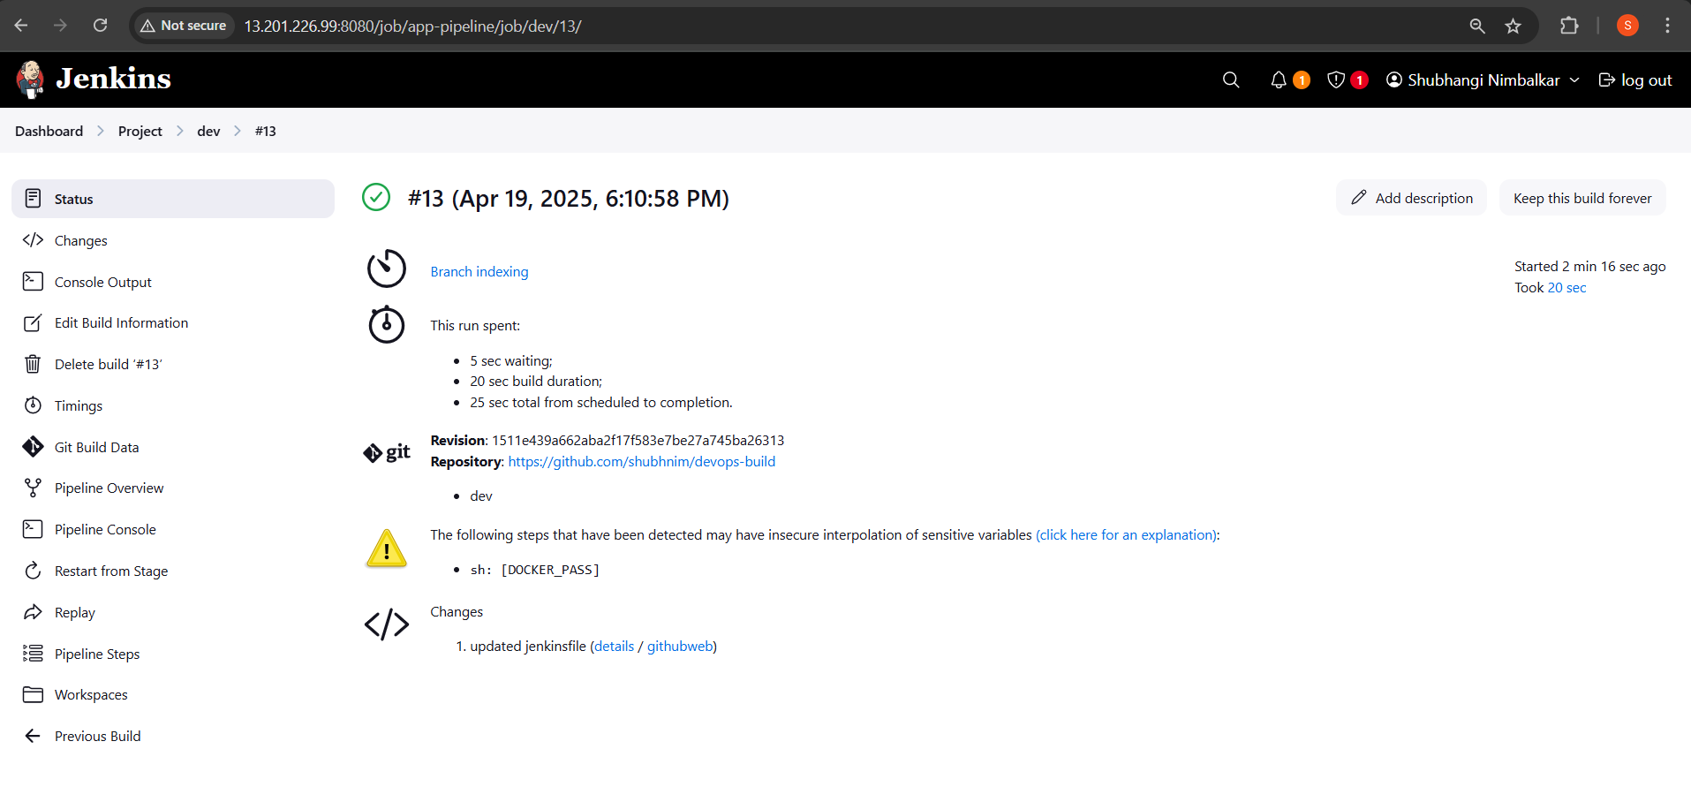

Application deployed on EC2:

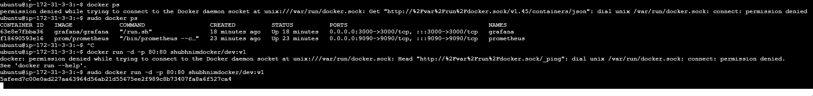

**dev merged into master branch**  
Built Docker image & pushed to **DockerHub prod repo**

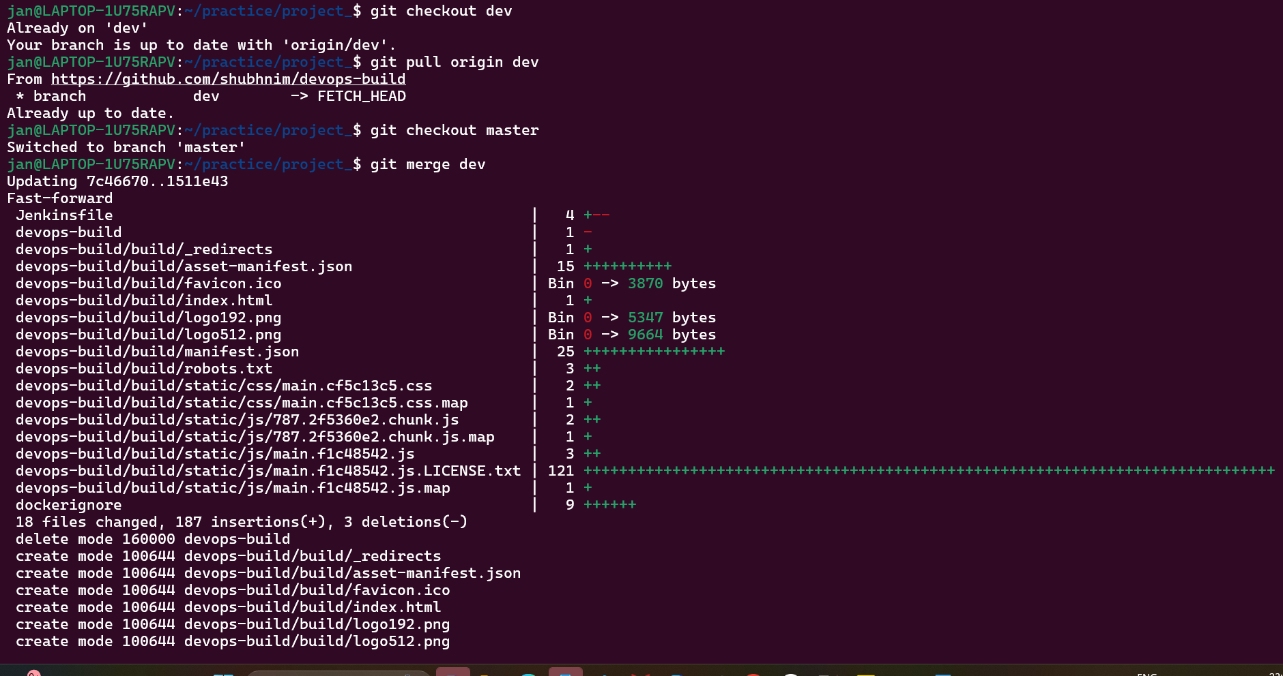  
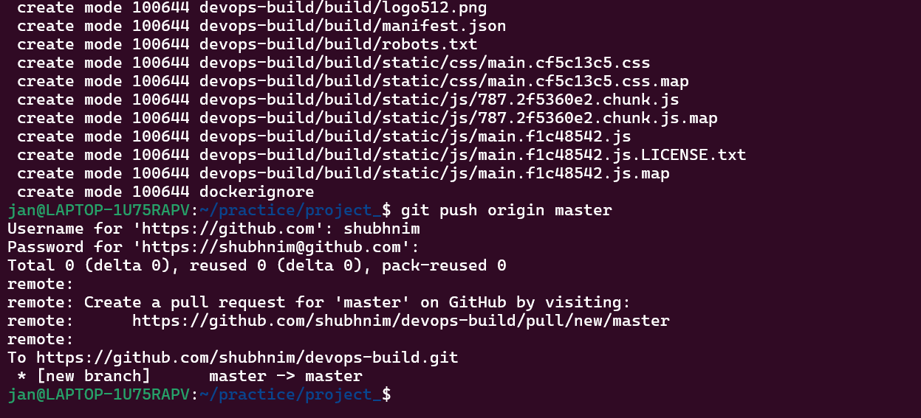

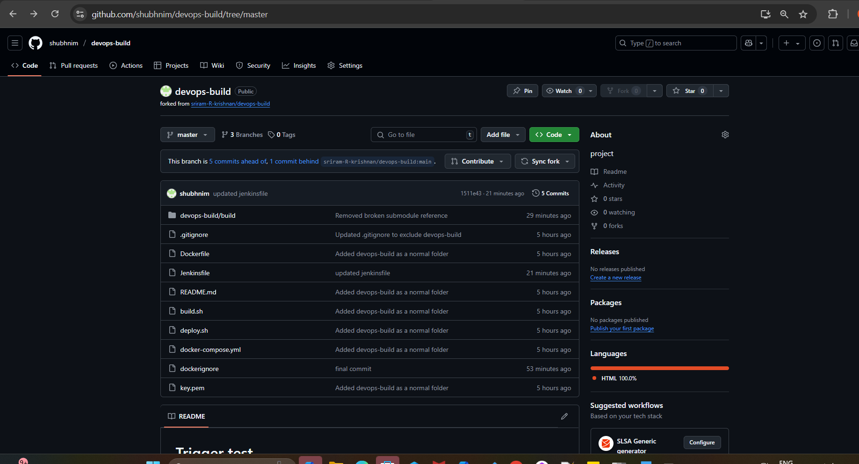

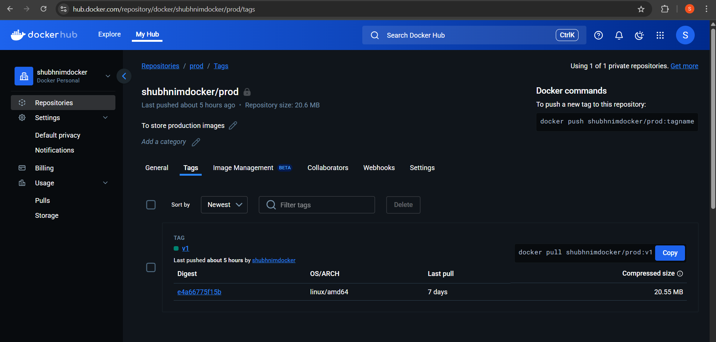

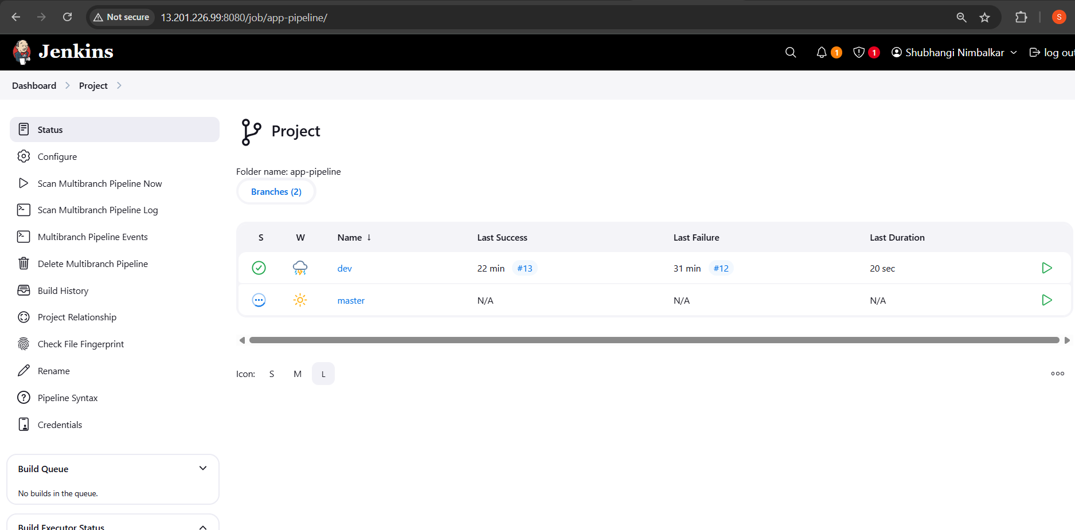

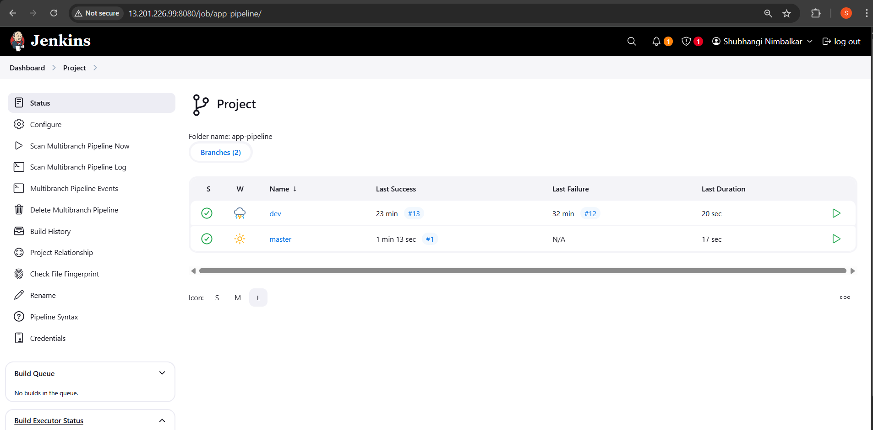

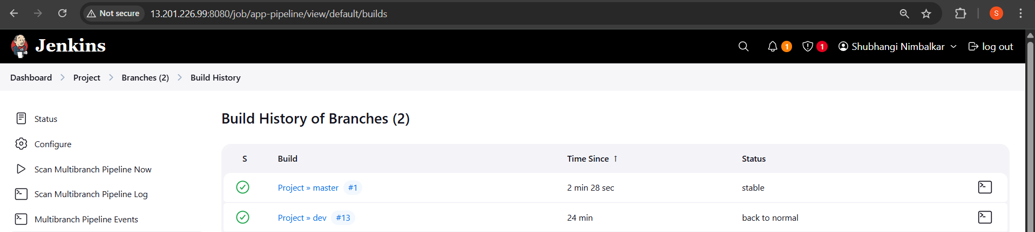

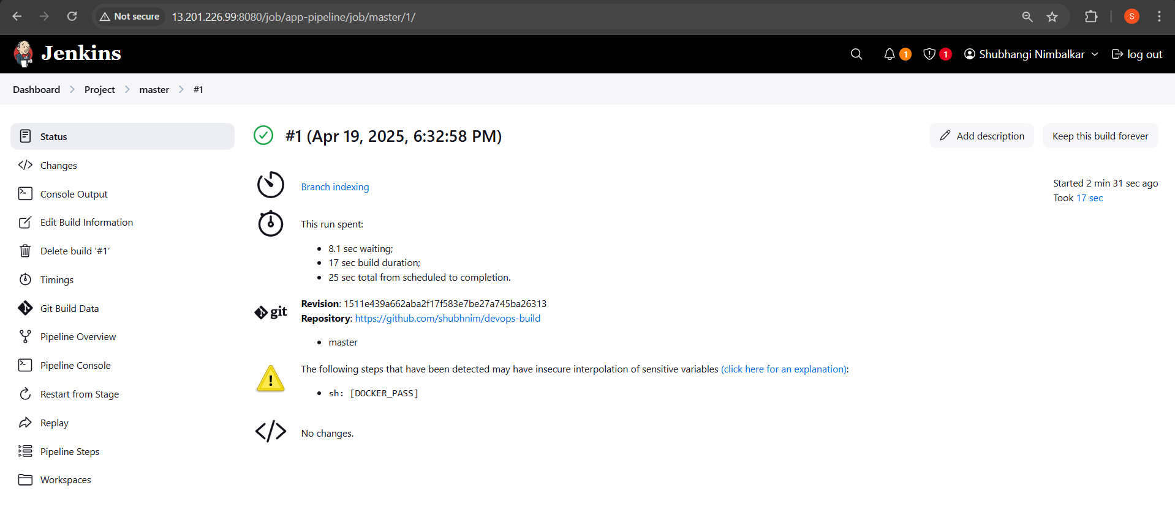

Monitoring:

Setup a monitoring system to check the health status of the application. (Open-source)

**Installed Prometheus** on EC2 server: 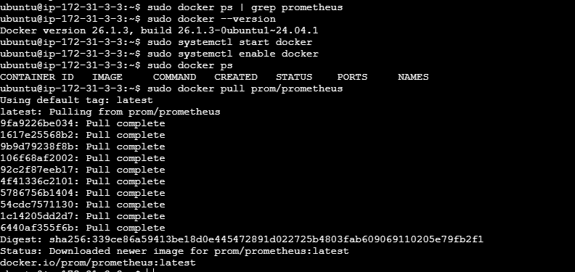

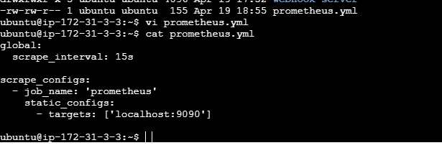

**Run Prometheus**:

sudo docker run -d \

-p 9090:9090 \

--name prometheus \

-v /home/ubuntu/prometheus.yml:/etc/prometheus/prometheus.yml \

prom/prometheus

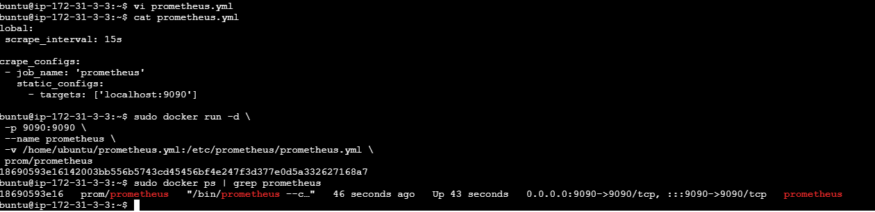

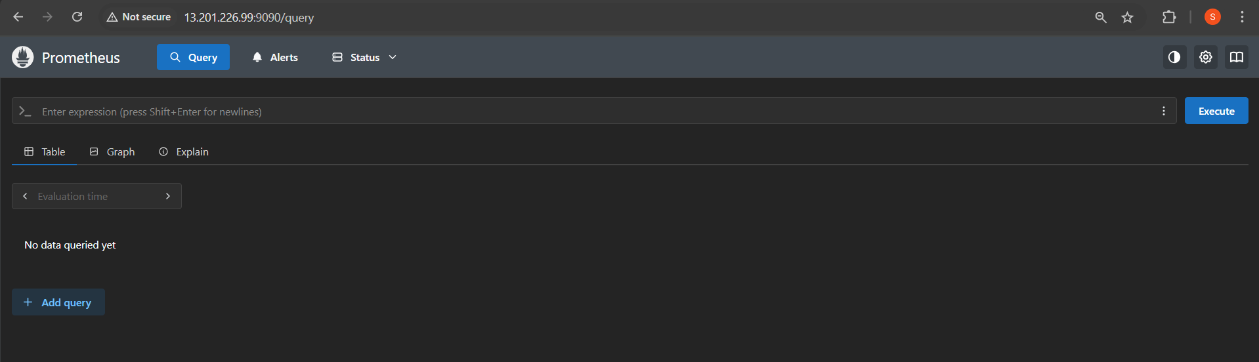

Grafana:

Start Grafana in **detached** mode (-d).

Expose port 3000 on your EC2 instance for Grafana's web interface.

Link the **Prometheus** container to Grafana, so it can access Prometheus metrics.

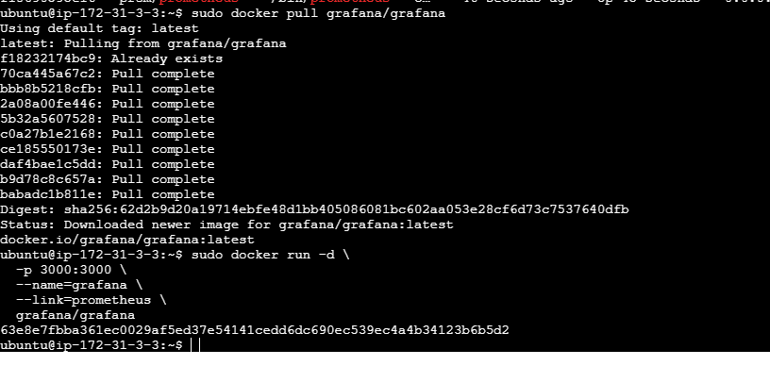

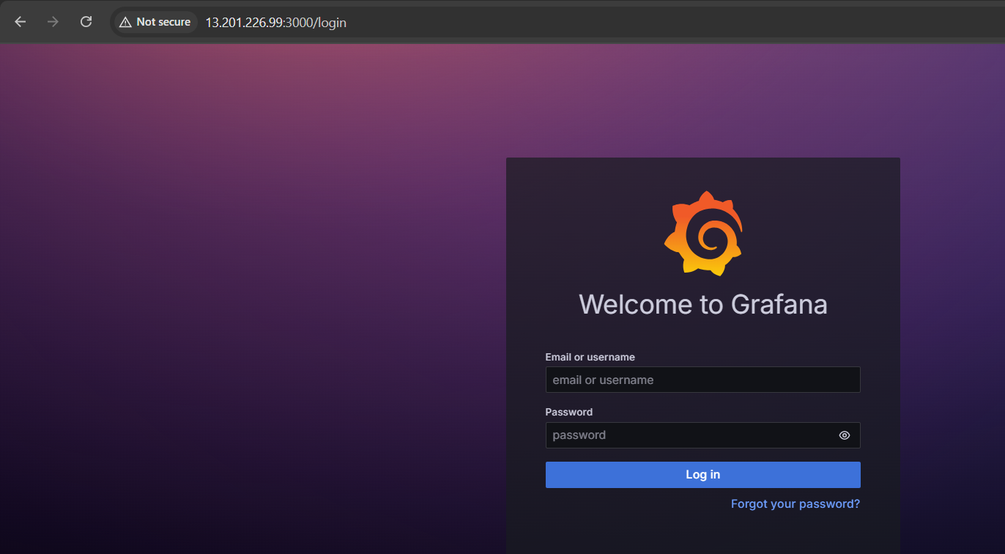

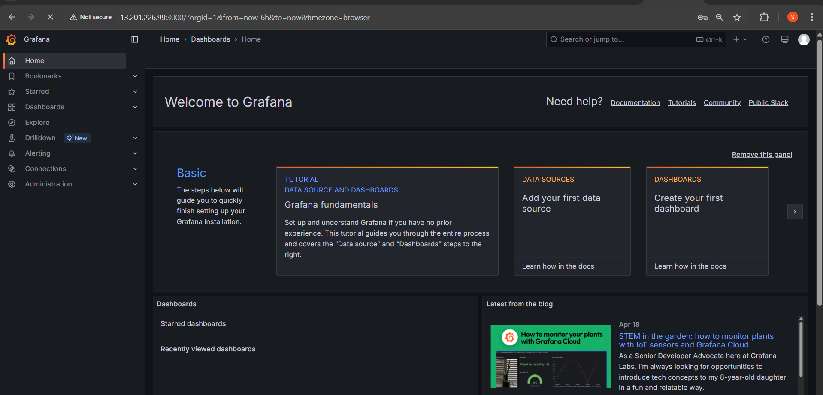

**Configure Prometheus as a Data Source in Grafana**:

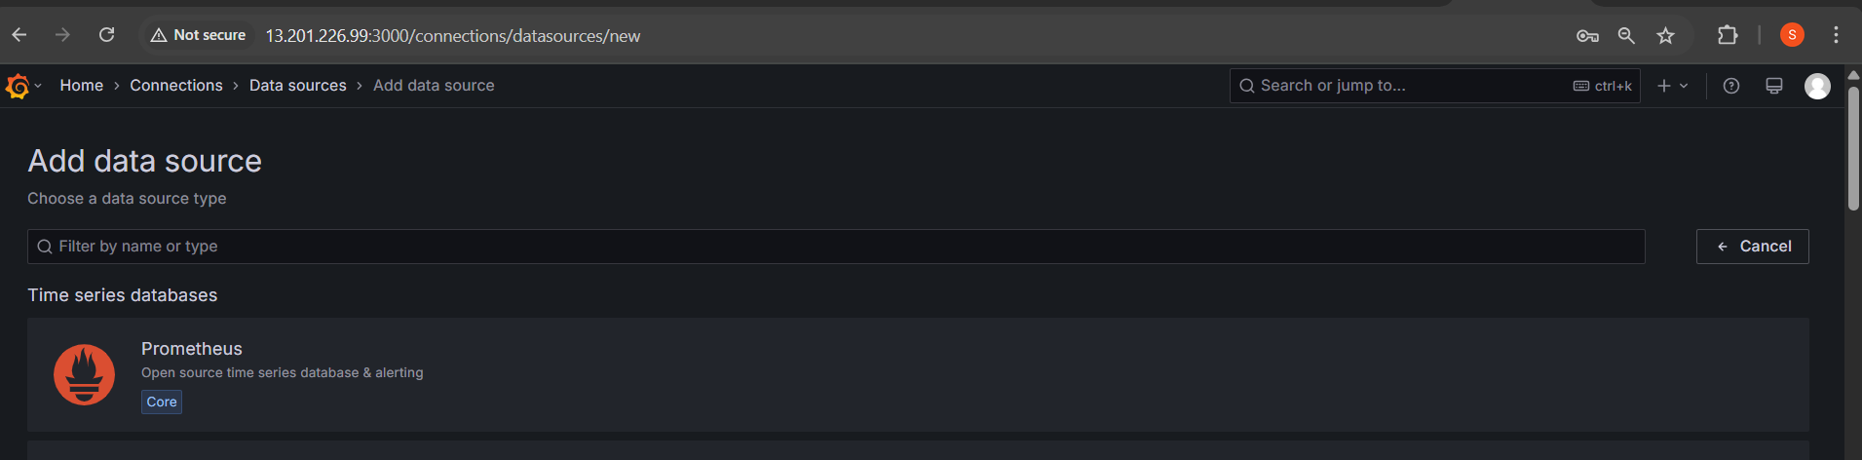

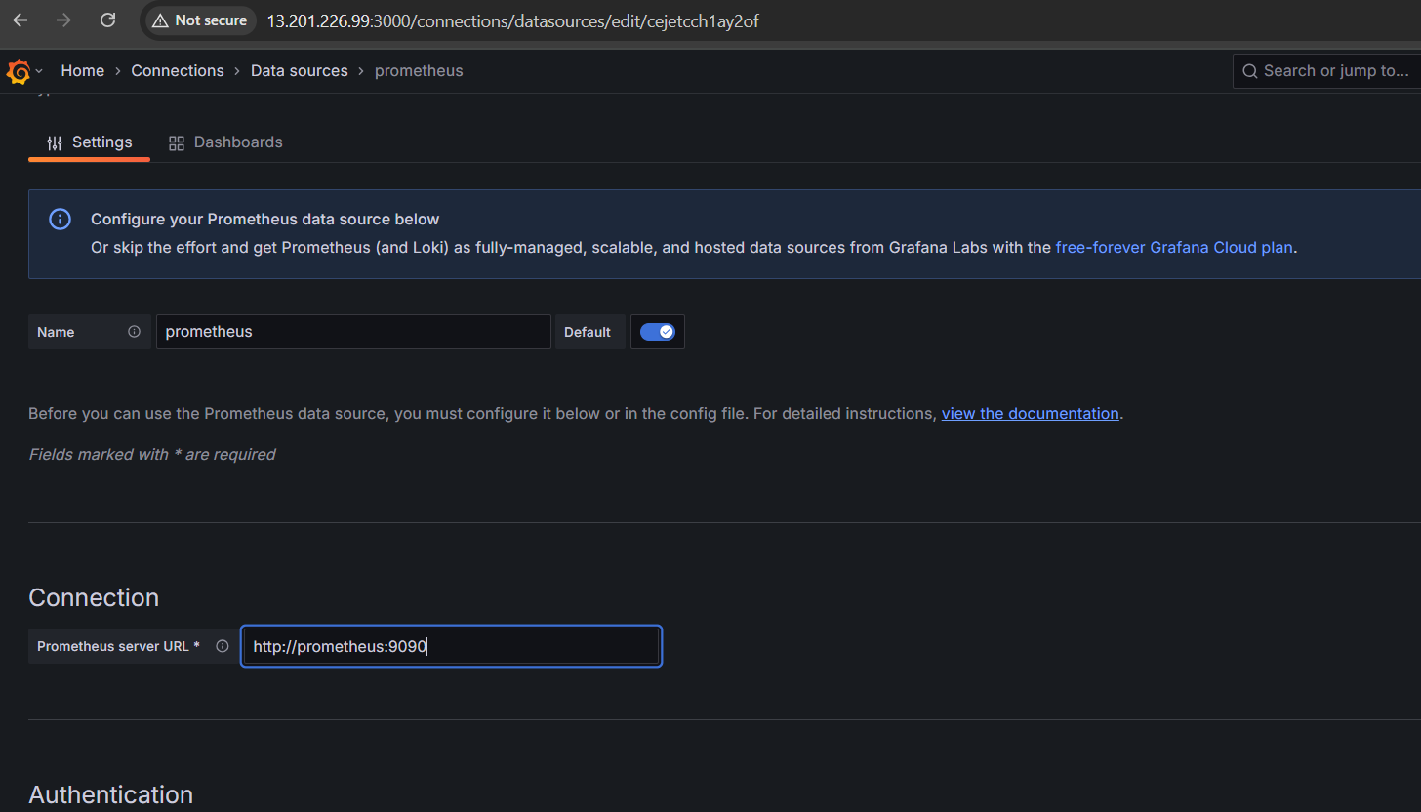

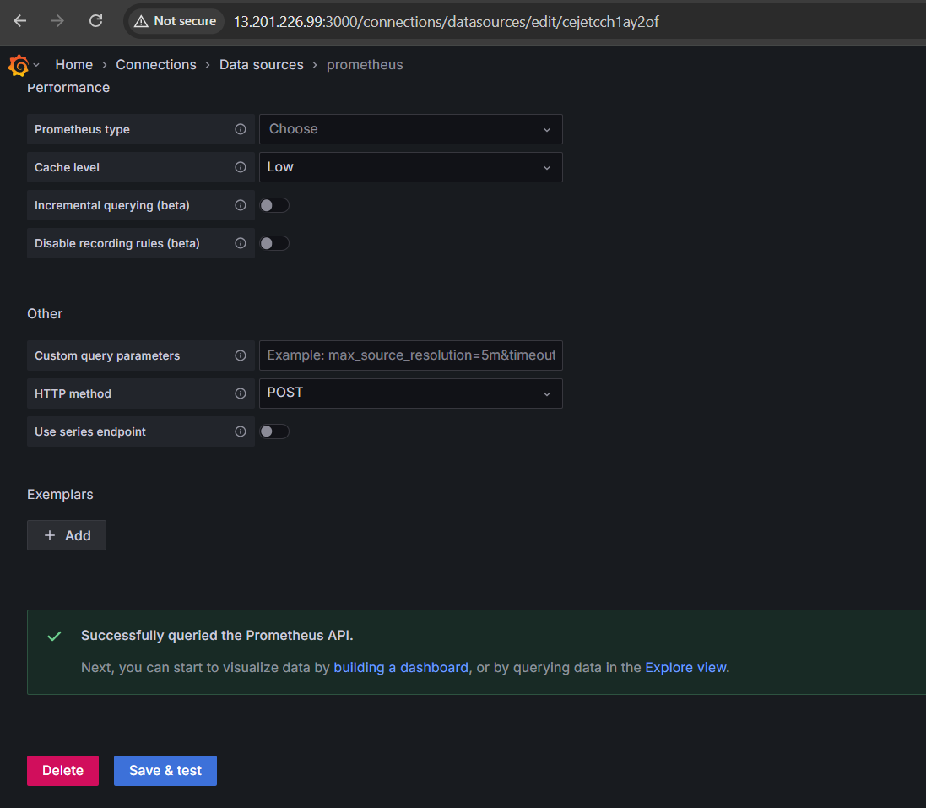

**Create a Dashboard**: